REVIEW OF ENVIRONMENTAL FACTORS
Proposed Seniors Housing Development
at
15-17 Combles Parade & 2-4 Hamel Road, Matraville NSW 2160
Lots 34 & 36 Deposited Plan 36250

February 2024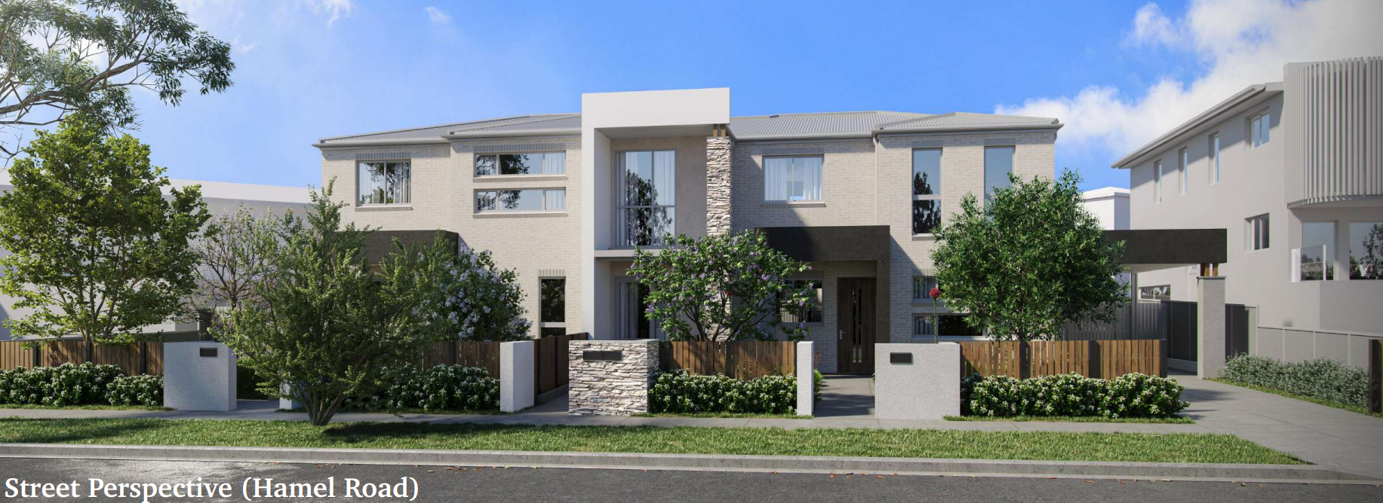 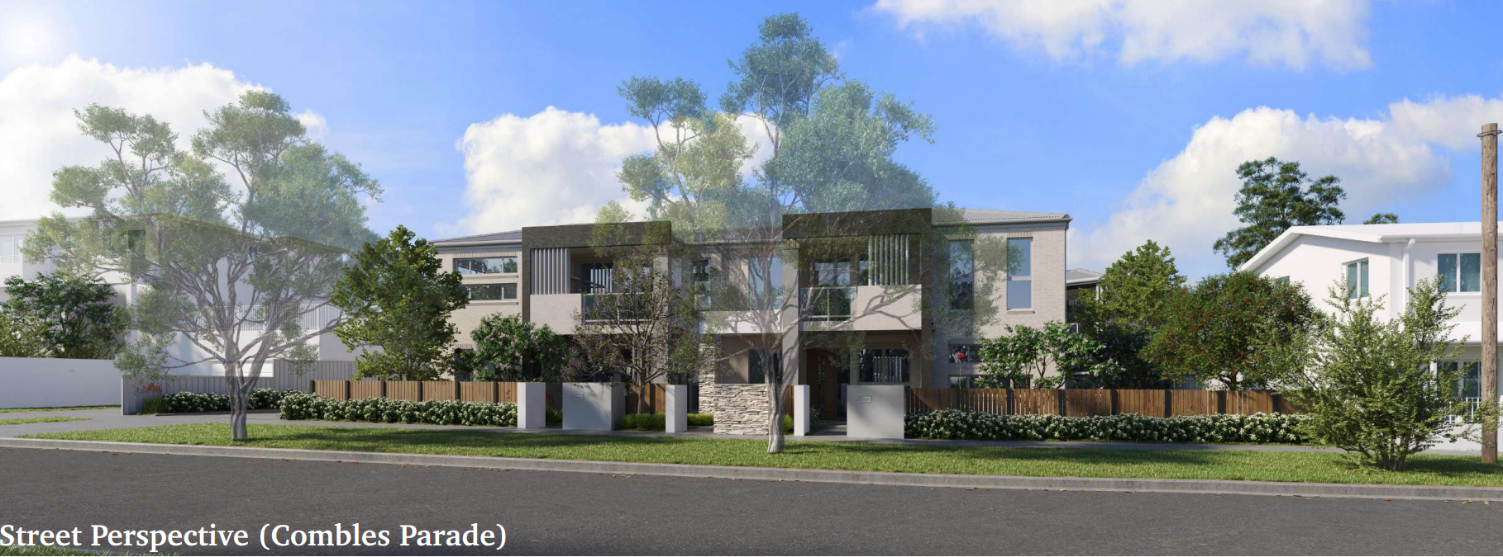


Acknowledgement of Country
Homes NSW acknowledges that it stands on Aboriginal land. We acknowledge the Traditional Custodians of the land and we show our respect for Elders past, present and emerging through thoughtful and collaborative approaches to our work, seeking to demonstrate our ongoing commitment to providing places in which Aboriginal people are included socially, culturally and economically.
Published by
nsw.gov.au/departments-and-agencies/homes-nsw
REVIEW OF ENVIRONMENTAL FACTORS
First published: February 2024
Department reference number: BGYF2

On February 1 2024, Homes NSW, a division of the Department of Communities and Justice (DCJ) was formed. It has brought together the housing and homelessness services of DCJ with the NSW Land and Housing Corporation (LAHC), Aboriginal Housing Office (AHO) and key worker functions from across government under one roof.

Department of Communities and Justice
Homes NSW
Postal address: Locked Bag 5022, Parramatta NSW 2124
http://www.nsw.gov.au/homes-nsw
ABN 24 960 729 253

This document may only be used for the purposes associated with the subject activity to which this Part 5 Review of Environmental Factors relates and to the extent authorised under the provisions of the Environmental Planning and Assessment Act 1979 and Environmental Planning and Assessment Regulation 2021, for the express purposes set out under that legislation, and may not otherwise be copied, reproduced, distributed or used without the written permission of the authors.

DOCUMENT CONTROL REGISTER
The following register documents the preparation and issue of this Part 5 Review of Environmental Factors (REF), prepared by Barker Ryan Stewart for the LAHC.
No | Date | Version | Change since last version | Pages
1 | January 2024 | 1 | Initial version | All
2 | February 2024 | 2 | LAHC Review | All

DOCUMENT SIGN-OFF
REF Prepared & Peer Reviewed by:
Having prepared the Review of Environmental Factors:
- I have declared any possible conflict of interests (real, potential, or perceived) to the A/Executive Director of Strategy and Origination, Housing Portfolio, Homes NSW.
- I do not consider I have any personal interests that would affect my professional judgement.
- I will inform the A/Executive Director of Strategy and Origination, Housing Portfolio, Homes NSW. as soon as I become aware of a possible conflict of interest.
Name: | Adam Coburn
Designation: | Managing Director NSW- Mecone Group Pty Ltd
Signature: |  | Date: 23 January 2024
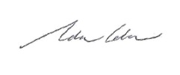
Peer reviewed by:
Name: | Louise Gibson
Designation: | Senior Planning Officer, Homes NSW
Signature: |  | Date: 26 February 2024

REF Reviewed & Endorsed by:
I certify that I have reviewed and endorsed the contents of this REF document, and, to the best of my knowledge, it is in accordance with the EP&A Act, the EP&A Regulation and the Guidelines approved under clause 170 of the EP&A Regulation, and the information it contains is neither false nor misleading.
Name: Carolyn Howell
Designation: Manager, Planning & Assessment, Homes NSW
Signature: 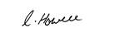 | Date: 26 February 2024
REF Authorised for Issue by:
Having authorised the issuing of this Review of Environmental Factors:
- I have declared any possible conflict of interest (real, potential, or perceived) to the A/Executive Director of Strategy and Origination, Housing Portfolio, Homes NSW.
- I do not consider I have any personal interests that would affect my professional judgement.
I will inform the A/Executive Director of Strategy and Origination, Housing Portfolio, Homes NSW as soon as I become aware of a possible conflict of interest.
Name: | Ambrose Marquart
Designation: | Acting Director, Portfolio Services, Homes NSW
Signature: |  | Date: | 27.02.2024

Contents
1 Executive Summary 8
2 Introduction 9
3 Existing Site & Locality 10
3.1 Existing Site and Immediately Adjoining Development 10
3.2 Site Description 13
3.3 Neighbouring Development and Locality 13
4 Project Description 16
4.1 Demolition 16
4.2 Removal of Trees 16
4.3 Proposed Dwellings 17
4.4 Supporting information 21
5 Zoning and Permissibility 24
6 Planning and Design Framework 25
6.1 Environmental Planning and Assessment Act 1979 25
6.2 Biodiversity Conservation Act 2016 (BC Act) 25
6.3 Other Acts 26
6.4 Environmental Planning and Assessment Regulation 2021 26
6.5 State Environmental Planning Policy (Housing) 2021 29
6.6 Other State Environmental Planning Policies 44
Randwick Local Environmental Plan 2012 (RLEP 2012) 46
6.7 46
6.8 Randwick Development Control Plan 2013 46
7 Notification, Consultation and Consideration of Responses 49
7.1 Council Notification 49
7.2 Notification of Occupiers of Adjoining Land and Other Persons 51
7.3 Notification of Specified Public Authorities 52
8 Review of Environmental Factors 53
8.1 Neighbourhood Character 53
8.2 Bulk and Density 53
8.3 Streetscape 54
8.4 Visual Impact 54
8.5 Privacy 55
8.6 Solar Access 55
8.7 Overshadowing 56
8.8 Traffic & Parking 56
8.9 Flora and Fauna 57
8.10 Heritage (European / Indigenous) 57
8.11 Soils / Contamination / Acid Sulfate Soils / Salinity 58
8.12 Drainage / Flood Prone Land / Hydrology/ Water Quality 59
8.13 Bushfire Prone Land 59
8.14 Noise and Vibration 59
8.15 Air Quality 60
8.16 Waste Minimisation 60
8.17 Resource Use & Availability 61
8.18 Community / Social Effects 61
8.19 Economic Impact 62
8.20 Cumulative Impact Assessment 62
9 Conclusion 63
9.1 Summary of Key Issues Raised in Assessment 63
9.2 Recommendation 63

List of Figures
Figure 1 Location Plan (Source: SIX Maps) 10
Figure 2 Development site – 15-17 Combles Parade, Matraville (Source: Mecone,2024) 11
Figure 3 Development site – 2-4 Hamel Road, Matraville (Source: Mecone, 2024) 11
Figure 4 Adjoining development – Dual Occupancy at 11 Combles Parade, Matraville (Source: Mecone, 2024) 12
Figure 5 Adjoining property – Multi Unit Housing at 19 Combles Parade, Matraville (Source: Mecone, 2024) 12
Figure 6 Proposed Development at 6 Hamel Road Matraville (Source: ShoreHouse Projects via Randwick DA Tracker) 13
Figure 7 Example of multi-unit townhouse development at 12-22 Hamel Road (east of the site) (Source: Google Streetview, 2023) 14
Figure 8 Example of renewed housing stock at 23 Combles Parade (North of the site), (Source: Google Streetview, 2023) 14
Figure 9 Photomontage of the development (Source: Stanton Dahl Architects, 2023) 17
Figure 14 Landscape Plan (Source: Botanique Design/ Stanton Dahl Architects, 2023) 20
Figure 15 Extract from Land Zoning map of RLEP 2012 (Source: Mecone Mosaic) 24
Figure 16 Map of Properties Notified of the Proposed Development (Source: Homes NSW) 51

List of Tables
Table 1 Compliance with subsection 3 of Section 5.5 of the EP&A Act 1979 25
Table 2 Environmental Planning and Assessment Regulation 2021 Section 171 26
Table 3 Compliance with relevant provisions under sections Part 5, Division 8 of the SEPP for ‘seniors’ housing development without consent’ carried out by LAHC 29
Table 4 Compliance with section 84(2) (c) (iii), 85, 88, 89 of the Housing SEPP 2021 31
Table 5 Non-Discretionary standards for Independent Living units (Section 108) 32
Table 6 Accessibility and useability standards [Schedule 4] 33
Table 7 Seniors Living Urban Design Guidelines departures 38
Table 8 Good Design for Social Housing – Relevant Goals & Principles 40
Table 9 Response to Design Principles (Part 5, Division 8) 42
Table 10 Compliance with other applicable State and Environmental Planning Policies 44
Table 11 Randwick Local Environmental Plan 2012 46
Table 12 Randwick Development Control Plan 2013 47
Table 13 Issues raised in Council submission 49

- Executive Summary
The subject site is located at 15- 17 Combles Parade, 2-4 Hamel Road. Matraville, and is legally described as Lots 34 and 36 in Deposited Plan 36250. The proposed seniors housing development is described as follows:
Demolition of existing structures, removal of trees, and the construction of 8 independent living seniors housing units comprising 8 x 1 bedroom units, with associated landscaping and fencing, surface parking for 4 cars, and consolidation into a single lot.
The proposed activity is located in a prescribed zone and seniors housing can therefore be carried out by the Land and Housing Corporation, now Homes NSW, without consent under the provisions of Part 5, Division 8, Chapter 3 of the State Environmental Planning Policy (Housing) 2021 (Housing SEPP) as it does not result in more than 40 dwellings on the site and does not exceed 9.5 metres in height. The provisions under Clause 108B of the Housing SEPP have been complied with.
Demolition has been considered as part of the proposed activity. Demolition is permitted with consent under the provisions of the applicable local environmental planning instrument (Randwick Local Environmental Plan 2012) and is therefore permitted without consent under the provisions of the Housing SEPP. The removal of trees on the site is covered by the definition of consent under Section 6 of the Housing SEPP. It has therefore been incorporated in this review of environmental factors under Part 5 of the Environmental Planning and Assessment Act 1979 (EP&A Act) and Part 8 of the Environmental Planning and Assessment Regulation 2021 (EP&A Regulation).
The REF demonstrates the following:
- from an analysis of the potential environmental impacts associated with the proposed activity, it has been concluded that the preparation of an Environmental Impact Statement is not required;
- based on a review of the potential environmental impacts resulting from the proposed activity it has been determined that, subject to implementation of mitigation measures to be incorporated as identified requirements, the activity will not have any significant adverse impact on the environment;
- the proposed activity will not have any effect on matters of national significance and its approval under the Commonwealth Environment Protection and Biodiversity Conservation Act 1999 is not required;
- the design of the proposed activity has adequately taken into account design principles and better practices set out in the Seniors Living Policy: Urban Design Guidelines for Infill Development and taken into consideration Good Design for Social Housing and LAHC’s Design Requirements;
- the site planning and design of the proposed activity adequately address the applicable local environmental planning and development controls of Randwick City Council;
- BASIX and NatHERS certificates and stamped plans have been submitted for the proposed activity demonstrating compliance with the State Government’s environmental sustainability targets; and
- there are no separate approvals, authorisations or notifications required in relation to the proposed activity prior to determination under Part 5 of the EP&A Act or under any other Acts.
Randwick City Council and occupiers of adjoining land were notified of the proposed activity on 6 November 2023 under the provisions of Housing SEPP. Email responses were received from Council dated 17 November 2023, 28 November and 1 December 2023. Submissions were received from 3 residents during the notification period. Responses to the comments received from both Council and the community are provided in Section 6.1 of this REF.
The proposed activity, if carried out in accordance with the environmental mitigation measures outlined in the REF, will not result in any significant and long term negative impacts on the environment and can proceed subject to the implementation of the Identified Requirements included in the Activity Determination.
Note:
State Environmental Planning Policy Amendment (Housing) 2023
On 14 December 2023, amendments were made to State Environmental Planning Policy (Housing) 2021 (Housing SEPP). This amending policy is referred to in Schedule 7A Savings and transitional provisions as State Environmental Planning Policy Amendment (Housing) 2023.
Clause 8 (2) of Schedule 7(A) of Housing SEPP 2021 provides that the amendments made on 14 December 2023 do not apply to an activity by the Land and Housing Corporation where notice of the activity has been provided to Council under 108C(1)(b)(i) before the amending policy was made and further that the activity is determined before 20 December 2024. This activity for seniors housing satisfies both requirements and therefore State Environmental Planning Policy Amendment (Housing) 2023 does not apply to this activity.

- Introduction
This Review of Environmental Factors (REF) under Part 5 of the Environmental Planning and Assessment Act 1979 (EP&A Act) is for an activity involving the Demolition of existing structures, removal of trees, and the construction of 8 independent living seniors housing units comprising 8 x 1 bedroom units, with associated landscaping and fencing, surface parking for 4 cars, and consolidation into a single lot at 15-17 Combles Parade and 2- 4 Hamel Road, Matraville
The activity* will be carried out by, or on behalf of, LAHC and is ‘development without consent’ under the Housing SEPP.
This REF has been prepared by Mecone Group Pty Ltd on behalf of LAHC in satisfaction of the provisions of Part 5 of the Environmental Planning & Assessment Act 1979 (EP&A Act) and Part 8 of the Environmental Planning & Assessment Regulation 2021 (EP&A Regulations).
A Statement of Compliance accompanying this REF certifies that in accordance with the requirements of the EP&A Act, all matters affecting or likely to affect the environment by reason of the proposed activity have been taken into account to the fullest extent possible and the activity will not have a significant impact on the environment.
*Note: The proposed development is permitted without consent and is therefore subject to environmental impact assessment as an ‘activity’ under Part 5 of the Environmental Planning and Assessment Act 1979.

- Existing Site & Locality
  - Existing Site and Immediately Adjoining Development
The site is located in the Randwick Local Government Area (LGA) and comprises 2 residential allotments. A location plan is provided at Figure 1Error! Reference source not found.
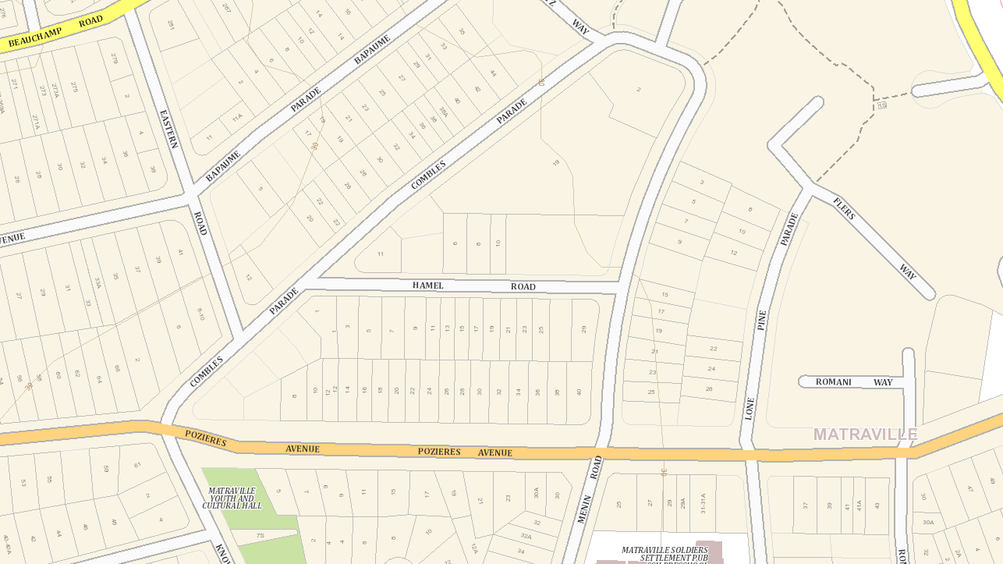
Figure 1 Location Plan (Source: SIX Maps)

15-17 Combles Parade and 2-4 Hamel Road both currently contain a single storey brick dual occupancy with a pitched tiled roof. (refer to photographs at Figure 2 & 3).
The property immediately to the west (11 Combles Parade) contains a two storey, brick dual occupancy with pitched tiled roof (refer photograph at Figure 3). 19 Combles Parade to the east of the site contains a two storey, multi-unit housing development (refer to photograph at Figure 4). Also to the east of the site is 6 Hamel Road which has been recently demolished and has approval for a two storey attached dual occupancy and strata subdivision as per development application DA968/2018 (refer to photograph at Figure 5).
To the south of the site on Hamel Road, there are several single storey brick dwellings, as well as two storey dwellings and dual occupancies. Housing stock is similar to the north of the site at Combles Parade. Two storey, multi-unit housing and terrace style dwellings (similar to the development at 19 Combles Parade), is observed to the north east of the subject site.

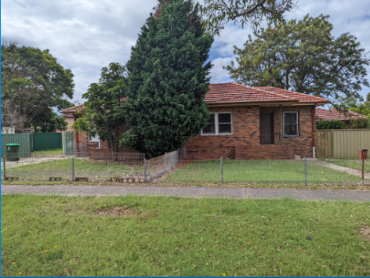
Figure 2 Development site – 15-17 Combles Parade, Matraville (Source: Mecone,2024)

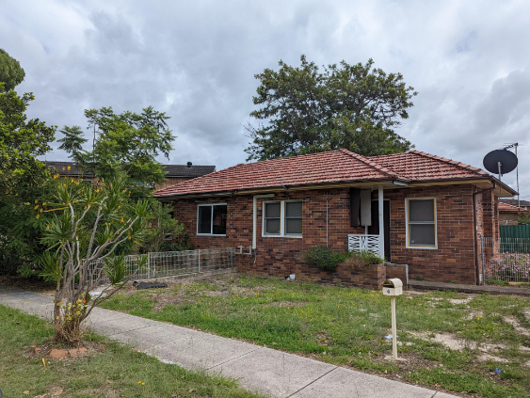
Figure 3 Development site – 2-4 Hamel Road, Matraville (Source: Mecone, 2024)

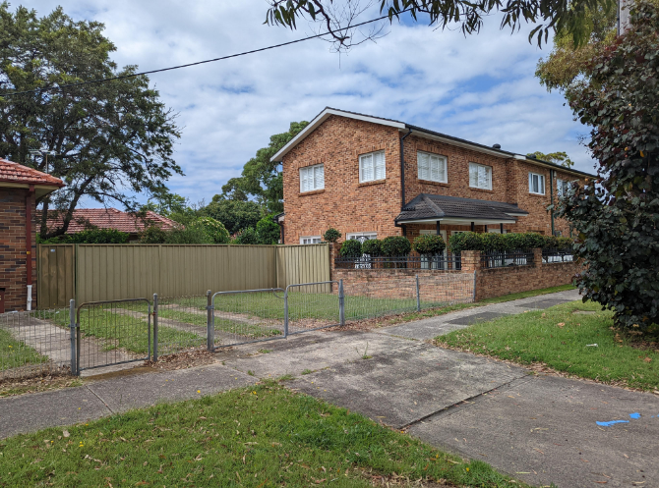
Figure 4 Adjoining development – Dual Occupancy at 11 Combles Parade, Matraville (Source: Mecone, 2024)

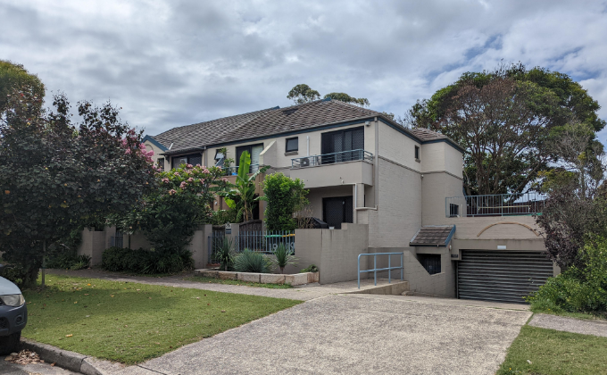
Figure 5 Adjoining property – Multi Unit Housing at 19 Combles Parade, Matraville (Source: Mecone, 2024)

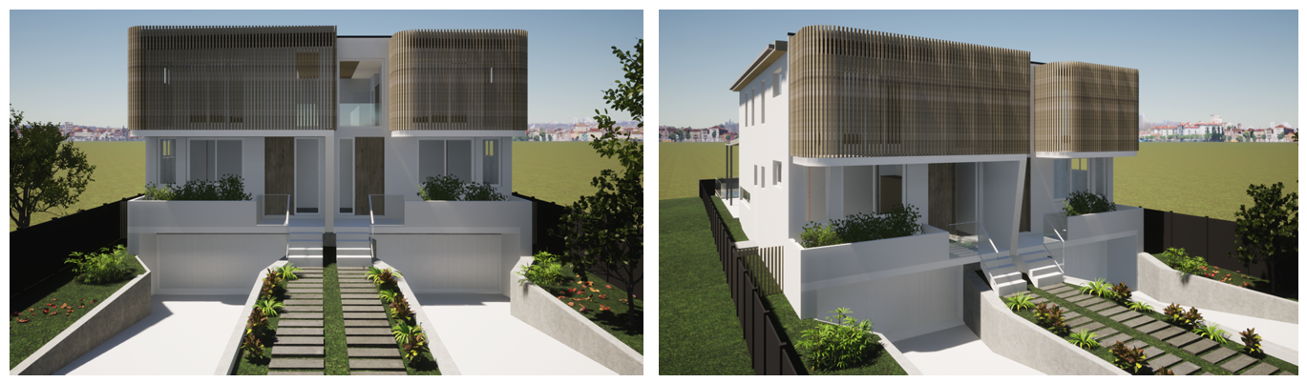
Figure 6 Proposed Development at 6 Hamel Road Matraville (Source: ShoreHouse Projects via Randwick DA Tracker)
  - Site Description
Copies of the Section 10.7(2) & (5) Planning Certificates Nos 68273 and 68274 dated 19.01.2024 are provided in Appendix F.
The site has a combined surveyed area of 1,205m². The site is an irregular polygon with dual street frontage. The frontage to Combles Parade is approximately 32.05m and the frontage to Hamel Road is approximately 26.5m (refer to the submitted Detail and Level Survey Plan in Appendix D).
The site is relatively flat with a gentle fall from east to west. The topography of the site enables stormwater to drain to Hamel Road.
The site is not within a flood planning area and is not subject to flood related development controls.
There are 3 trees within the site, including one large tree at the rear of lot 34 and two small trees at the front of lot 36. Several street trees are present along Combles Parade and Hamel Road.
Water, electricity, gas, sewer and telephone facilities are available to the site. Water, electricity, gas and telephone services are located along the road alignment of Combles Parade and/or Hamel Road. Sewer services are located within the front setback of 2-4 Hamel Road (refer to the submitted Detail and Level Survey for the location of available services at Appendix D).
There are no encumbrances indicated on title, section 10.7 certificates or on the submitted Survey Plan.
  - Neighbouring Development and Locality
The site is located within an established residential area which is characterised by older style single and double storey brick dwellings, generally with pitched, tiled roofs. The area also features several two storey dual occupancies and multi-unit housing developments, with densities typically increasing to the east and north east of the subject site. These dwellings have been typically constructed within the last 20 years however, more recent housing stock, including renovated dwellings generally reflect the character of the area, adopting elements of brick in façade treatments and pitched roofs (refer to photographs at Figures 7 & 8). The recent approval of the adjacent development at 6 Hamel Road (Figure 6) suggests a transition to more modern housing design may occur in coming years.
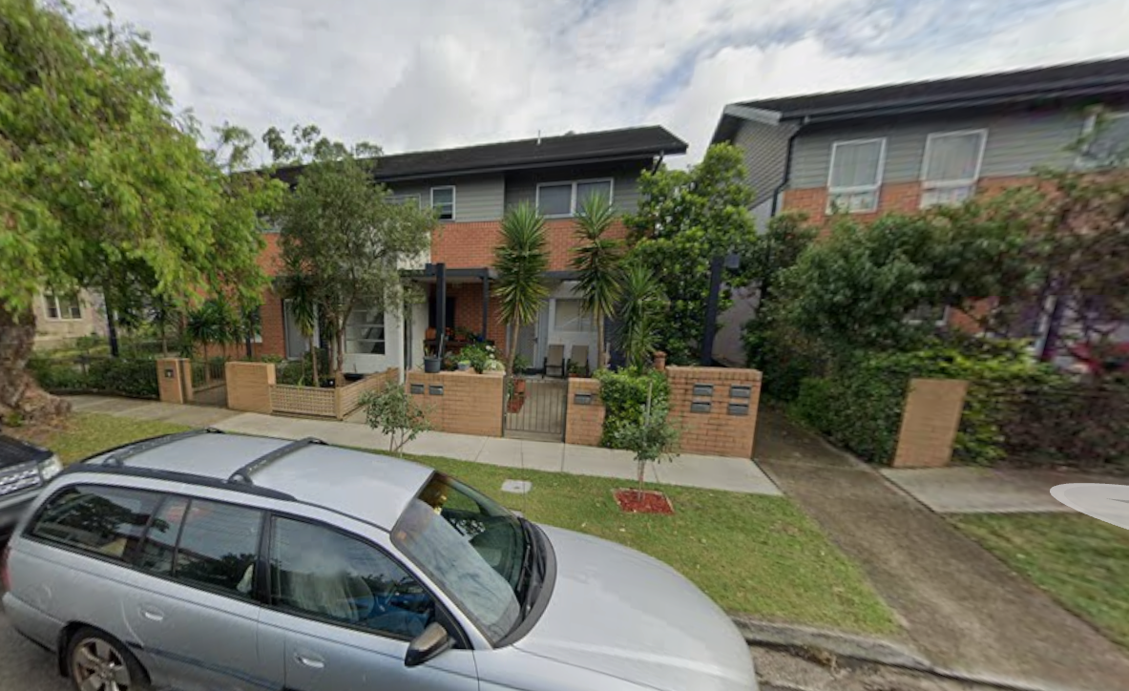
Figure 7 Example of multi-unit townhouse development at 12-22 Hamel Road (east of the site) (Source: Google Streetview, 2023)

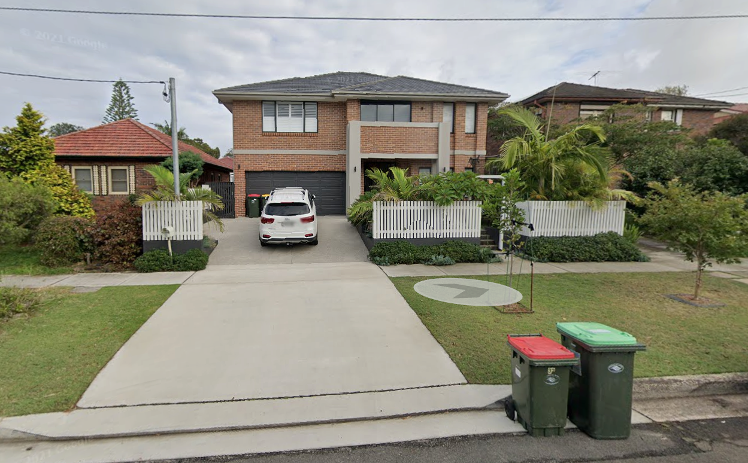
Figure 8 Example of renewed housing stock at 23 Combles Parade (North of the site), (Source: Google Streetview, 2023)

The closest bus stop to the subject site is located on Beauchamp Road, approximately 350m walking distance to the north. This bus stop services Route 375 between East Gardens and Randwick. The frequency of bus services at this bus stop is consistent with the service frequency requirements for an accessible area as defined within the Housing SEPP and quoted below:
(c) 400m walking distance of a bus stop used by a regular bus service, within the meaning of the Passenger Transport Act 1990, that has at least 1 bus per hour servicing the bus stop between—
(i) 6am and 9pm each day from Monday to Friday, both days inclusive, and
(ii) 8am and 6pm on each Saturday and Sunday.
The nearest light rail station is Juniors Kingsford Light Rail, approximately 3.5km north of the subject site. While the light rail is not within walking distance of the site, regular bus services are available on Anzac Parade (approximately 550m east of the site) providing connection to the light rail.
Local shops and services are available approximately 700m west of the subject site in Matraville, along Bunnerong Road. These include a supermarket, restaurants, medical centres, dentist, service station and specialty stores. The site is located within walking distance of the local public school (Matraville Soldier’s Settlement Public School) and several local parks and amenities.

- Project Description
The main features of the development are summarised as follows:
- site preparation works including demolition of 2 x dual occupancies and structures, and associated earthworks;
- removal of 3 trees within the subject site;
- construction of 8 x 1 bedroom independent living units split evenly between 2 blocks (4 units per block);
- surface parking for 4 vehicles;
- associated landscaping and fencing;
- provision of rooftop Photovoltaic Panels;
- removal of existing redundant driveways with reconstruction of kerb and gutter and street stormwater extension;
- construction of new driveway, retaining walls and upgrade of footpath; and
- consolidation of the 2 lots into a single lot.
  - Demolition
The proposed activity includes demolition of 2 x dual occupancy dwelling houses and associated structures at 15-17 Combles and 2-4 Hamel Road, Matraville. The dwellings and associated structures are indicated for demolition on the submitted demolition plan (refer to Appendix A).
  - Removal of Trees
The Arboricultural Impact Assessment and Tree Management Plan reviewed a total of 10 trees, 3 of which are located within the subject site, 1 tree on the neighbouring property to the southeast on Combles Parade and 6 trees on the adjacent road reserves.
Trees to be removed:
Within the site, 3 trees are proposed for removal to accommodate the proposed development. None of these trees are considered significant or worthy of special measures to ensure their preservation. A variety of low maintenance tree plantings with mature heights ranging from 6m – 12m are proposed in the Combles Parade and Hamel Road front setbacks and towards the middle of the site to compensate for the removal of existing trees.
Trees to be retained:
A total of 7 trees are proposed for retention.
Along the Combles Road frontage 4 trees are to be retained as well as 2 trees within the Hamel Road frontage. The proposed development has been designed to avoid these trees and therefore no impacts are expected provided appropriate measures are properly specified and controlled in accordance with the Arboricultural Tree Protection Plan (Refer to Appendix J).
Within the street frontage of Hamel Road 2 trees are proposed to be retained without any adverse effects if appropriate protective measures are properly specified and controlled in accordance with the Arboricultural Tree Protection Plan Refer to Appendix J).
All trees on neighbouring properties will be retained.
  - Proposed Dwellings
The proposal includes the construction of 8 independent living units across 2 buildings. Each building will contain 4 units with 2 on the ground floor and 2 on the first floor. Of the 8 independent living units, 4 (ground floor units) have been designed as accessible units. A photomontage of the proposed development is provided at Figure 9 & 10.

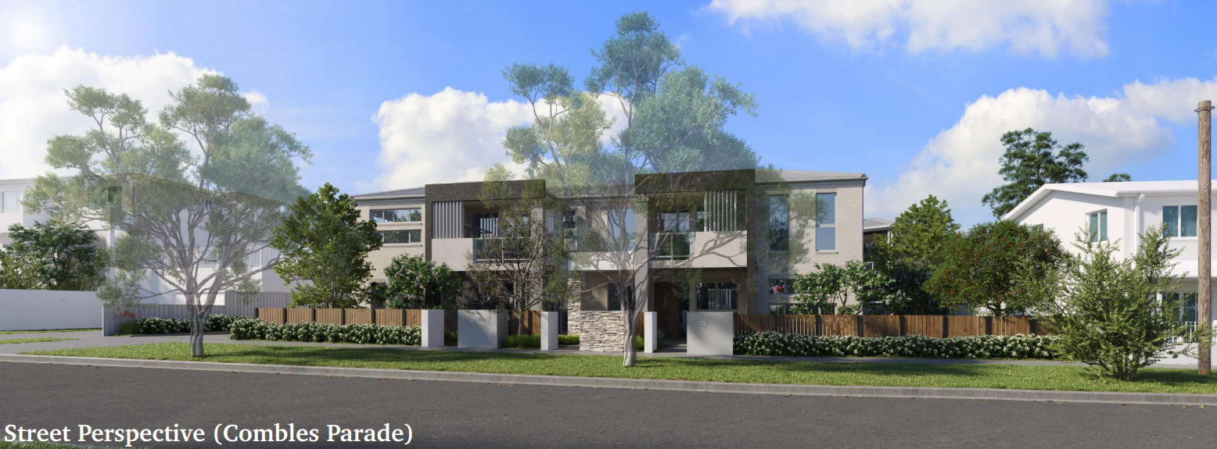
Figure 9 Photomontage of the development (Source: Stanton Dahl Architects, 2023)
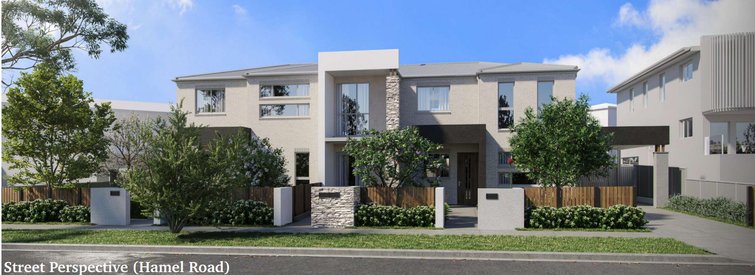
Figure 10 Street Elevation (Source: Stanton Dahl Architects, 2023)

The proposed housing represents a contemporary, high quality design. The use of face brick and cladding for external walls and metal roofing is consistent with the developing character of the Matraville locality. Of the 8 proposed units 4 will address Combles Parade (Units 5 and 6 on the ground floor and Units 7 & 8 on the first floor) and the other 4 will address Hamel Road (Units 1 and 2 on the ground floor and Units 3 & 4 on the first floor). Living areas, windows and private open space facing the street for passive surveillance. The development is detailed in Figures 11-13, below.

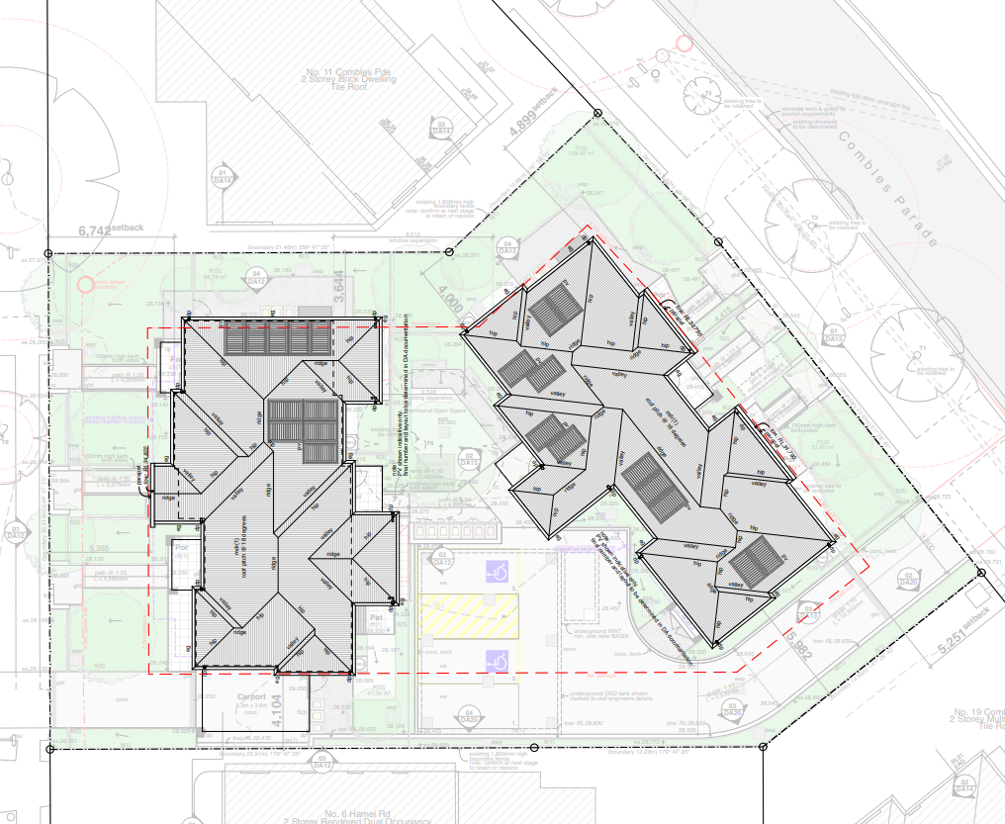
Figure 11 Site & Roof Plan (Source: Stanton Dahl Architects,2023)

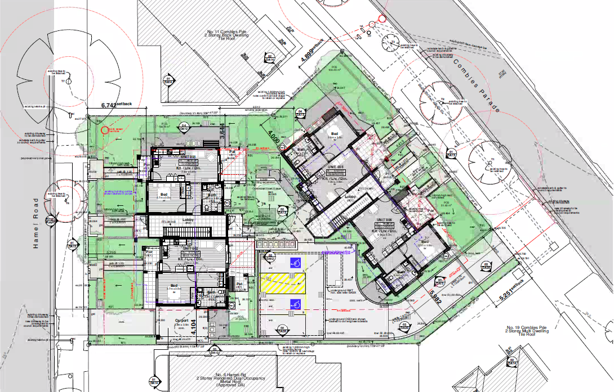
Figure 12 Ground floor plan (Source: Stanton Dahl Architects,2023)
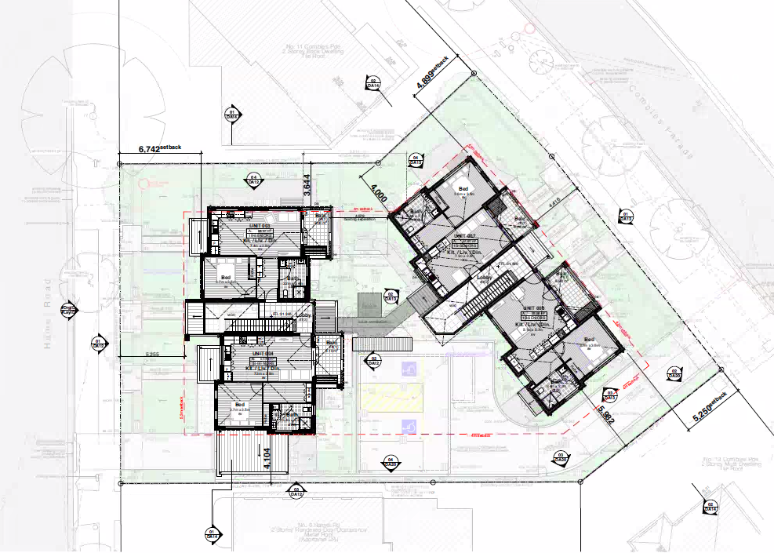
Figure 13 First Floor Plan (Source: Stanton Dahl Architects,2023)

Moderate cut is proposed to provide a level building platform. This degree of cut is within Council’s DCP standards. A retaining wall is proposed along the eastern boundary from the Combles Parade frontage to round the front building line on Hamel Road as shown on the Site Plan (refer to Appendix A).
New landscape plantings will consist of a mixture of native trees, shrubs and groundcovers, which will enhance landscaped setbacks and contribute to the streetscape. A variety of new landscape plantings, including trees capable of reaching a mature height of6m – 12m, will be provided as part of the proposed landscaping to offset the proposed tree removal and to enhance the appearance of the site and the microclimate for new occupants and neighbours (refer to Landscape Plan in Appendix B).
Metal fencing between 1.2m and 2.4m in height is to be installed along the side boundaries as well as internally from the site between units. Shrub planting adjacent to the fencing will provide further privacy to neighbouring properties. An extract from the Landscape Plan is provided at Figure 14.
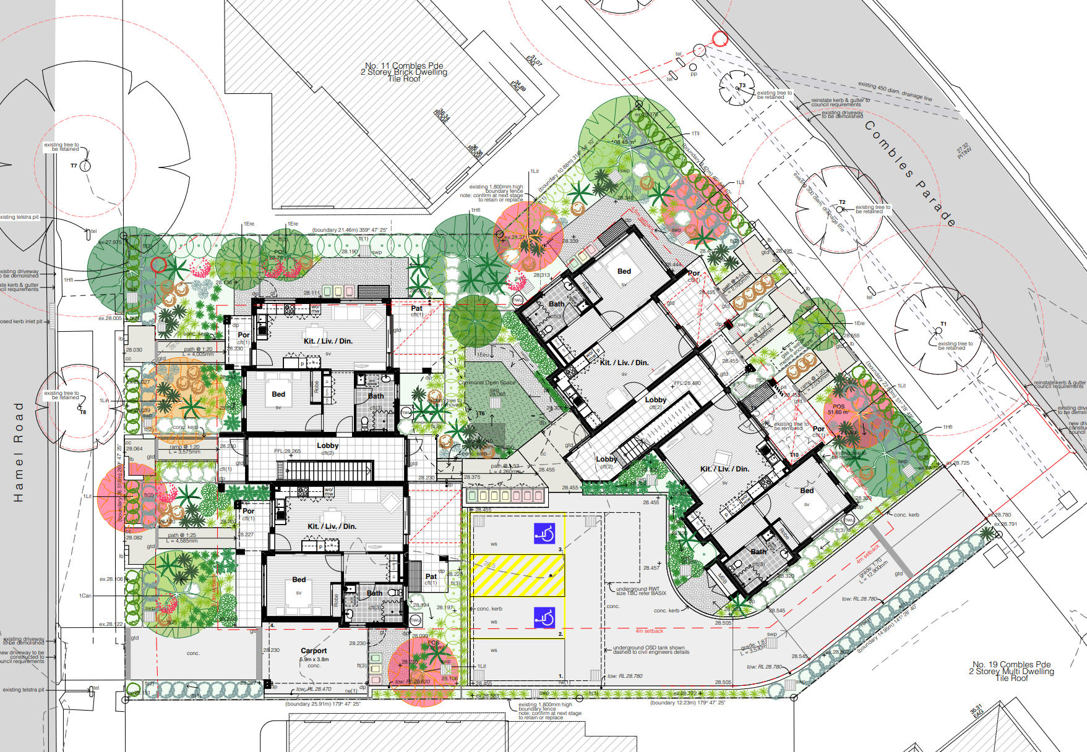
Figure 14 Landscape Plan (Source: Botanique Design/ Stanton Dahl Architects, 2023)

Each unit will be provided with its own enclosed private open space area in the form of either a courtyard or balcony directly accessible from the internal living areas. An informal common open space area is also provided in the middle of the site between Units 1 and 5 towards the western portion of the site.
A total of 4 at-grade car parking spaces will be provided on the site, including 2 accessible spaces. A communal parking area located within the centre of the site contains 3 carparking spaces with the fourth space designed within a carport located along the site’s far eastern side boundary. Vehicular access is provided to on-site car parking via Combles Parade and Hamel Road respectively.
Stormwater will be collected via a series of stormwater pits and drains on the site connected to a below-ground on-site detention tank which will ultimately drain to the existing stormwater network along Hamel Road. An Identified Requirement has been imposed requiring the OSD to be increased in size in line with Randwick City Council’s drainage requirements (IR 82). A kerb inlet pit is proposed to be installed at the front of 2-4 Hamel Road to accommodate site drainage.
Roof water will be collected from downpipes and connected to a below-ground rainwater tank of 2,700L capacity for recycling and use on landscaped areas with overflow connected to the underground detention tank.
  - Supporting information
The proposal is detailed in the following plans, drawings and specialist reports and supporting information:
Plans, Drawings & Supporting Document Details
The development is outlined in the following plans and drawings:
Title / Name: | Drawing No. / Document Ref | Revision / Issue: | Date [dd.mm.yyyy] | Prepared by:
Architectural – Appendix A
Coversheet & location plan | DA00 | DA 2 | 25.10.2023 | Stanton Dahl & Associates Pty Ltd
Location Analysis | DA01 | DA 2 | 25.10.2023 | Stanton Dahl & Associates Pty Ltd
Site Analysis | DA02 | DA 2 | 25.10.2023 | Stanton Dahl & Associates Pty Ltd
Character Analysis | DA03 | DA 2 | 25.10.2023 | Stanton Dahl & Associates Pty Ltd
Development Data & Notes | DA04 | DA 2 | 25.10.2023 | Stanton Dahl & Associates Pty Ltd
Demolition Plan | DA05 | DA 2 | 25.10.2023 | Stanton Dahl & Associates Pty Ltd
Cut and Fill Plan | DA06 | DA 2 | 25.10.2023 | Stanton Dahl & Associates Pty Ltd
Site & Ground Floor Plan | DA07 | DA 2 | 25.10.2023 | Stanton Dahl & Associates Pty Ltd
Site & First Floor Plan | DA08 | DA 2 | 25.10.2023 | Stanton Dahl & Associates Pty Ltd
Site & Roof Plan | DA09 | DA 2 | 25.10.2023 | Stanton Dahl & Associates Pty Ltd
Floor & Roof Plan | DA10 | DA 2 | 25.10.2023 | Stanton Dahl & Associates Pty Ltd
Landscape, Deep Soil and GFA diagrams | DA11 | DA 2 | 25.10.2023 | Stanton Dahl & Associates Pty Ltd
Elevations (Block A) | DA12 | DA 2 | 25.10.2023 | Stanton Dahl & Associates Pty Ltd
Elevations (Block B) | DA13 | DA 2 | 25.10.2023 | Stanton Dahl & Associates Pty Ltd
Sections | DA14 | DA 2 | 25.10.2023 | Stanton Dahl & Associates Pty Ltd
Shadow Analysis (Sht 1) | DA15 | DA 2 | 25.10.2023 | Stanton Dahl & Associates Pty Ltd
Shadow Analysis (Sht 2) | DA16 | DA 2 | 25.10.2023 | Stanton Dahl & Associates Pty Ltd
Shadow Analysis (Sht 3) | DA17 | DA 2 | 25.10.2023 | Stanton Dahl & Associates Pty Ltd
Shadow Analysis (Sht 4) | DA18 | DA 2 | 25.10.2023 | Stanton Dahl & Associates Pty Ltd
3D Perspectives Fence | DA19 | DA 2 | 25.10.2023 | Stanton Dahl & Associates Pty Ltd
Fence & Retaining Wall Details | DA20 | DA 2 | 25.10.2023 | Stanton Dahl & Associates Pty Ltd
Landscape Plan – Appendix B
Landscape Plan | L01 | Rev 1 | 13.09.2023 | Stanton Dahl & Associates Pty Ltd
Landscape Details a | L02 | Rev 1 | 13.09.2023 | Stanton Dahl & Associates Pty Ltd
Civil Plans – Appendix C
Notes and Legends | C01 | 3 | 24.10.2023 | Greenview Consulting Pty Ltd
Ground Floor Drainage Plan | C02 | 3 | 24.10.2023 | Greenview Consulting Pty Ltd
Road Frontage Plan Site | C03 | 3 | 24.10.2023 | Greenview Consulting Pty Ltd
Catchment Plan | C04 | 1 | 24.10.2023 | Greenview Consulting Pty Ltd
Site Stormwater Details Sheet 1 | C05 | 3 | 24.10.2023 | Greenview Consulting Pty Ltd
Notes & Legends | C06 | 3 | 24.10.2023 | Greenview Consulting Pty Ltd
Civil Design | C07 | 3 | 24.10.2023 | Greenview Consulting Pty Ltd
Surveys – Appendix D
Survey Plan Showing Detail and Levels | 1 of 2 | B | 27.01.2022 | Mepstead & Associates
Survey Plan Showing Detail and Levels | 2 of 2 | B | 27.01.2022 | Mepstead & Associates
Survey Plan Showing Path Long sections | 1 of 2 | B | 24/10/22 | Mepstead & Associates
Survey Plan Showing Path Long Sections | 2 of 2 | B | 24/10/22 | Mepstead & Associates
Notification Plans – Appendix E
Cover Sheet | 1 | 1 | 23.10.2023 | Stanton Dahl & Associates Pty Ltd
Site/Landscape Plan | 2 | 1 | 23.10.2023 | Stanton Dahl & Associates Pty Ltd
Development Data | 3 | 1 | 2.11.2023 | Stanton Dahl & Associates Pty Ltd
Elevations | 4 | 1 | 23.10.2023 | Stanton Dahl & Associates Pty Ltd
Schedule of Finishes | 5 | 1 | 23.10.2023 | Stanton Dahl & Associates Pty Ltd
Shadow Diagrams | 6 | 1 | 23.10.2023 | Stanton Dahl & Associates Pty Ltd
BASIX – Appendix K
BASIX | BASIX Certificate No 1379283M | - | 28.09.2023 | Greenview Consulting Pty Ltd
NatHERS Certificate – Appendix N
NatHers Certificate Unit 1 | Certificate No 0008956864 | - | 28.09.2023 | Greenview Consulting Pty Ltd
NatHERs Certificate Unit 2 | Certificate No 0008956831 | - | 28.09.2023 | Greenview Consulting Pty Ltd
NatHERS Certificate Unit 3 | Certificate No 0008956666 | - | 28.09.2023 | Greenview Consulting Pty Ltd
NatHERs Certificate Unit 4 | Certificate No 0008956732 | - | 28.09.2023 | Greenview Consulting Pty Ltd
NatHERS Certificate Unit 5 | Certificate No 0008956815 | - | 28.09.2023 | Greenview Consulting Pty Ltd
NatHERS Certificate Unit 6 | Certificate No 0008956765 | - | 28.09.2023 | Greenview Consulting Pty Ltd
NatHERS Certificate Unit 7 | Certificate No 0008956880 | - | 28.09.2023 | Greenview Consulting Pty Ltd
NatHERS Certificate Unit 8 | Certificate No 0008956856 | - | 28.09.2023 | Greenview Consulting Pty Ltd
Specialist Reports
Arboricultural Impact Appraisal and Method Statement – Appendix J | 6792.3 | - | 23.10.2023 | Redgum Horticultural
Access Report - Appendix H | 22412 | B | 22.10.2023 | Vista Access Architects Pty Ltd
BCA Report – Appendix L | P230121 | - | 16.10.2023 | BCA Vision
Geotechnical Investigation and Acid Sulfate Soil Assessment - Appendix P | 21/1721 | - | June 2021 | STS Geotechnics Pty Ltd
Waste Management Plan – Appendix R | 2701.21 | - | 25.10.2023 | Stanton Dahl & Associates Pty Ltd
Traffic and Parking Impacts Report - Appendix V | 210280 | A | 18.10.2023 | Greenview Consulting

Design Compliance and Checklists
Housing for Seniors – Checklist – Appendix O
Architect’s Certificate of Building Design Compliance, dated 19.09.2023 - Appendix M
Stormwater Engineer’s Certificate of Design Compliance, dated 25.10.2023 - Appendix M
Part 5 Activity Package Submission Checklist
Section 10.7 Planning Certificates – Appendix F
Section 10.7(2)(5) Planning Certificate No 68274– No. 2- 4 Hamel Road, Matraville NSW 2036, Lot 34 DP 36250, dated 19.01.2024.
Section 10.7(2)(5) Planning Certificate No 68273– No. 15-17 Combles Parade, Matraville NSW 2036, Lot 36 DP 36250, dated 19.01.2024.
Scope of notification, notification letters – Appendix G
Titles and Deposited Plans – Appendix Q
Certificate of Title Folio 34/36250, search date 21/07/2020
Certificate of Title Folio 36/36250, search date 21/07/2020
AHIMS – Appendix I
AHIMS Search Result, 2 Hamel Road, Matraville 2036 – 200m search buffer, date 31.10.2023

- Zoning and Permissibility
The site is zoned R2 Low Density Residential under Randwick Local Environmental Plan 2012 (RLEP 2012). The proposed development is defined as ‘seniors housing’ under the provisions of RLEP 2012 and is prohibited with in the R2 zone. However, section 79 of the Housing SEPP includes R2 Low Density zones as a prescribed zone, which prevails over the LEP Land Use Table. Further, section 80 of the Housing SEPP does not exclude the subject site. Therefore, seniors housing is permitted on the subject land with consent under the provisions of the SEPP pursuant to Part 5 Division 1.
The zoning context of the site is shown at Figure 15.
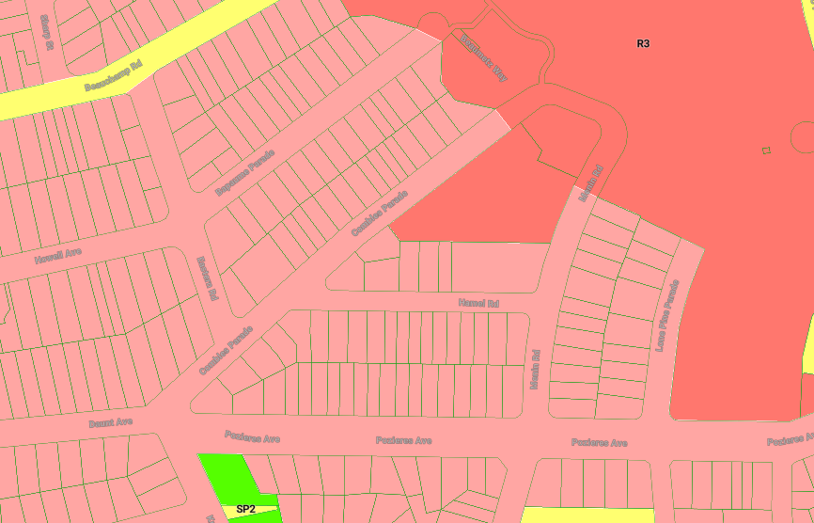
Figure 15 Extract from Land Zoning map of RLEP 2012 (Source: Mecone Mosaic)

The objectives for development in the R2 zone, as set out in RLEP 2012 are as follows:
- To provide for the housing needs of the community within a low density residential environment.
- To enable other land uses that provide facilities or services to meet the day to day needs of residents.
- To recognise the desirable elements of the existing streetscape and built form or, in precincts undergoing transition, that contribute to the desired future character of the area.
- To protect the amenity of residents.
- To encourage housing affordability.
- To enable small-scale business uses in existing commercial buildings.
The proposed development provides 8 dwellings for seniors housing in an area of high demand for these dwelling types. The proposed development will provide housing opportunities to some of the most vulnerable people in the community. This housing is designed specifically to meet the identified needs of senior residents and will therefore be consistent with this zone objective. The development has also been sympathetically designed to fit within its context and complement the surrounding area and streetscape. The proposal is therefore consistent with the relevant objectives of the R2 zone.
Section 108B of the Housing SEPP permits seniors housing development that may be carried out ‘with consent’ to be carried out by Land and Housing Corporation, as ‘development without consent’ subject to the provisions set out under that clause. Table 3 in subsection 6.5.1 of this REF demonstrates compliance with the relevant provisions of section 108B of the SEPP.

- Planning and Design Framework
  - Environmental Planning and Assessment Act 1979
    - Duty to consider environmental impact [Section 5.5]
Section 5.5(1) states that, for the purpose of attaining the objects of the EP&A Act relating to the protection and enhancement of the environment, a determining authority in its consideration of an activity shall, notwithstanding any other provisions of the Act or the provisions of any other Act or of any instrument made under the EP&A Act or any other Act, examine and take into account to the fullest extent possible all matters affecting or likely to affect the environment by reason of that activity.
Table 1 below demonstrates the effect of the proposed development activity on the matters listed for consideration in subsection 3 of Section 5.5.
Table 1 Compliance with subsection 3 of Section 5.5 of the EP&A Act 1979
Matters for consideration under sub-section 3 of Section 5.5 of the EP&A Act
Matter for consideration | Effect of Activity
Sub-section 3  Without limiting subsection (1), a determining authority shall consider the effect of an activity on any wilderness area (within the meaning of the Wilderness Act 1987) in the locality in which the activity is intended to be carried on. | No effect, as the site and surrounding areas are not within a wilderness area (within the meaning of the Wilderness Act 1987).
  - Biodiversity Conservation Act 2016 (BC Act)
Part 7 of the BC Act sets out the test for determining whether a proposed development or activity is likely to significantly affect threatened species, ecological communities or their habitats. For the purposes of Part 5 of the EP&A Act, an activity is to be regarded as an activity likely to significantly affect the environment if it is likely to significantly affect threatened species.
Based on the criteria set out in Section 7.3 of the BC Act, the proposed activity is unlikely to affect threatened species, ecological communities or their habitats and therefore no further assessment is necessary. This is because the land does not contain threatened species, endangered ecological communities or constitute habitat of threatened species or ecological communities.
The proposed activity will neither be a key threatening process and the land is not part of or in the vicinity of any declared area of outstanding biodiversity value. Therefore, no further assessment against the provisions of BC Act is necessary.
  - Other Acts
No other State and Commonwealth Acts are applicable to the proposed activity.
  - Environmental Planning and Assessment Regulation 2021
    - Factors that must be taken into account concerning the impact of an activity on the environment [Section 171]
For the purposes of Part 5 of the EP&A Act, the factors in Table 2 below have been taken into account in considering the likely impact of the proposed activity on the environment. The table and comments made in this section of the REF are not mutually exclusive and are to be read in conjunction with the other sections of the REF dealing with the environmental impacts of the proposed development activity.
Table 2 Environmental Planning and Assessment Regulation 2021 Section 171
Factors to be taken into account concerning the impact of an activity on the environment. |  | Comment
Is the activity of a kind for which specific guidelines are in force? If so the factors to be taken into account when considering the likely impact of the activity on the environment are those referred to in the guidelines. |  | No specific guidelines.  This does not include guidelines such as the Seniors Living Urban Design Guidelines, which are in force under other legislation or instruments.
Is the activity of any other kind for which general guidelines are in force? If so the factors to be taken into account when considering the likely impact of the activity on the environment are those referred to in those guidelines. |  | Yes - The Department of Planning and Environment issued “Guidelines for Division 5.1 assessments” made under Section 170 of the EP&A Regulation 2021.
Factors to be taken into account concerning the impact of an activity on the environment
Guidelines for Division 5.1 assessments require the following Environmental factors to be taken into account: | Relevant? |  | Impact Assessment
 | YES/NA |  | Temporary | Minor | Significant  [Note 1]
(a) environmental impact on the community | Yes |  | x | x
(b) transformation of a locality; | Yes |  |  | x
(c) environmental impact on the ecosystems of the locality; | Yes |  |  | x
(d) reduction of the aesthetic, recreational, scientific or other environmental quality or value of a locality; | Yes |  | x | x
(e) effect on a locality, place or building having aesthetic, anthropological, architectural, cultural, historical, scientific or social significance or other special value for present or future generations; | NA
(f) impact on the habitat of protected animals (within the meaning of Biodiversity Conservation Act 2016); | NA
(g) endangering of any species of animal, plant or other form of life, whether living on land, in water or in the air; | NA
(h) long-term effects on the environment; | Yes |  |  | x
(i) degradation of the quality of the environment; | Yes |  | x | x
(j) risk to the safety of the environment; | Yes |  | x | x
(k) reduction in the range of beneficial uses of the environment; | NA
(l) pollution of the environment; | Yes |  | x | x
(m) environmental problems associated with the disposal of waste; | Yes |  |  | x
(n) increased demands on resources (natural or otherwise) that are, or are likely to become, in short supply; | Yes |  |  | x
(o) cumulative environmental effect with other existing or likely future activities. | Yes |  |  | x
(p) impact on coastal processes and coastal hazards, including those under projected climate change conditions. [Note 2] | NA
(q) applicable local strategic planning statements, regional strategic plans or district strategic plans made under the Act, Division 3.1, | Yes – discussed below in subsection 5.4.2 below |  |  | x
(r) other relevant environmental factors. | Yes – discussed in Section 7 |  |  | x
Note 1: A significant impact triggers the preparation of an Environmental Impact Statement.
Note 2: The NSW Coastal Planning Guideline: Adapting to Sea Level Rise provides guidance on considering projected climate change conditions such as sea level rise.
The proposed seniors housing development is not expected to generate any significant or long-term impacts on the environment. The short term impacts, during construction, will be offset by positive social outcomes in the long term social benefits of providing affordable housing that meets the needs of the community. The applicable Local Strategic Planning Statement (LSPS) and Community Strategic Plan are considered below at Section 6.4.2 of this report.
    - Strategic Planning Framework
Greater Sydney Regional Plan – A Metropolis of Three Cities
The Greater Sydney Region Plan - A Metropolis of Three Cities was adopted in 2018 and “is built on a vision of three cities where most residents live within 30 minutes of their jobs, education and health facilities, services and great places. This is consistent with the 10 Directions in Directions for a Greater Sydney which establish the aspirations for the region over the next 40 years and are a core component of the vision and a measure of the Plan’s performance.”
Direction 4 of the regional plan is Housing the City which endeavours to provide residents with housing choice and includes the following objectives:
- Objective 10. Greater housing supply
- Objective 11. Housing is more diverse and affordable
This proposal, which will expand the supply of affordable housing, with 8 new seniors housing units, is consistent with these objectives. The site is located within the Randwick LGA which is part of the Eastern City District and the details of this Plan are provided below.
Our Greater Sydney 2056 Eastern City District Plan- connecting communities.
Our Greater Sydney 2056 Central City District Plan was adopted in March 2018 and covers the local government areas of Bayside, Burwood, City of Canada Bay, City of Sydney, Inner West, Randwick, Strathfield, Waverley and Woollahra. Similar to the main regional strategy, the Eastern City District Plan identifies planning priorities to achieve a liveable, productive and sustainable future for the District, which includes a priority to provide housing supply, choice and affordability, with access to jobs, services and public transport.
The plan states that the District is expected to see a 102% proportional increase in people aged 85 and over, and a 64% increase in the 65–84 age group, by 2036. This means 16% of the District’s population will be aged 65 or over in 2036, up from 13% in 2016. This will require more diverse housing opportunities, including medium density housing located in walkable neighbourhoods. This will enable older people to continue living in their community, where being close to family, friends and established health and support networks. This proposal will provide 8 seniors living units which will assist in providing alternative social housing types in an existing residential area.
The Randwick City Local Strategic Planning Statement
The Randwick City Local Strategic Planning Statement (Vision 2040) was adopted by Council in March 2020 and provides the framework for land use planning and decision making over the next 20 years. Vision 2040 identifies planning priorities and the actions the city will take to achieve them. These planning priorities are informed by 4 broad themes:
- Liveability
- Productivity
- Sustainability
- Infrastructure & Collaboration
The proposed development aligns with a series of planning priorities including:
- Planning Priority 1: Provide diverse housing options close to transport, services and facilities; and
- Planning Priority 2: Increase the supply of affordable rental housing stock to retain and strengthen our local community.
The proposed development will be contributing 8 seniors living units to the affordable housing supply in the Randwick LGA. It is diversifying the residential uses in Matraville by introducing seniors living housing options to accommodate the ageing population in the locality and is well serviced by existing public transport options.
Randwick City Council Community Strategic Plan 2022-2032
The Randwick City Council Community Strategic Plan 2017-2027 is a 10-year plan that sets out aspirations and priorities for the Randwick community. The Plan identifies 7 key strategy areas that include:
- Environment
- Arts and Culture
- Housing
- Integrated Transport
- Open Space and Recreation
- Inclusion
- Economic Development
Under these strategic goals there are objectives for Council to facilitate in partnership with the community, government agencies and businesses to achieve long term community outcomes.
The proposed development for 8 seniors living units is not in conflict with the Randwick Council Community Strategic Plan 2017-2027 and will provide new housing supply which supports affordable seniors housing within the LGA.
    - Activities in catchments [Section 171A]
The site is located within a regulated catchment, namely, the Sydney Harbour Catchment, as defined in Part 6.2 of State Environmental Planning Policy (Biodiversity and Conservation) 2021 (Biodiversity and Conservation SEPP). LAHC, as determining authority, when considering the likely impact on the environment of an activity proposed to be carried out in a regulated catchment, must take into account the controls on development set out in Part 6.2, Division 2 of the Biodiversity and Conservation SEPP. An assessment of these controls on development is provided in this REF. The assessment concludes that the proposed activity is unlikely to significantly impact the Sydney Harbour Catchment.
  - State Environmental Planning Policy (Housing) 2021
On 14 December 2023, the Housing SEPP 2021 was amended to include changes to the provision of new seniors housing development. Schedule 7A Savings and Transitional provisions under the Housing SEPP 2021 enable the continued application of the previous SEPP requirements for any application made prior to 14 December 2023. As the application was formally lodged on 6 November 2023, the savings provisions apply.
    - Development without Consent
Section 108B of the Housing SEPP permits seniors housing to be carried out by Land and Housing Corporation, , as ‘development without consent’ subject to the provisions set out under that section.
Table 3 Compliance with relevant provisions under sections Part 5, Division 8 of the SEPP for ‘seniors’ housing development without consent’ carried out by LAHC
Provision | Compliance
108A – Development to which Division applies  This Division applies to development for purposes of senior housing involving the erection of a building on land - | -
(a) on which development for purposes of seniors housing is permitted with consent under another environmental planning instrument, or | The site is zoned R2 Low Density Residential under Randwick Local Environmental Plan 2012 (RLEP 2012). The proposed development is defined as ‘seniors housing’ under the provisions of RLEP 2012 and is prohibited with in the R2 zone
(b) in a prescribed zone | The site is zoned R2 which is a prescribed zone in accordance with Part 5, Division 1, Clause 79 of the Housing SEPP.
108B – Seniors housing permitted without development consent  (1) Development to which this Division applies may be carried out by or on behalf of a relevant authority without development consent if - | -
(a) the relevant authority has considered the applicable development standards specified in sections 84(2)(c)(iii), 85, 88, 89 and 108, and | Consideration of the standards is provided in Table 4 & 5 below.
(b) will not result in a building with a height of more than 9.5 m, and | The maximum proposed building height is 7.5m.
(c) the development will result in more than 40 dwellings on the site. | The development is for 8 dwellings.
(2) State Environmental Planning Policy (Transport and Infrastructure) 2021, sections 2.15 and 2.17 apply to the development and, in the application of the clauses— | No consultation with authorities other than Council was required for this activity.
(a) a reference in section 2.15 to “this Chapter” is taken to be a reference to this section, and | Noted.
(b) a reference in the sections to a public authority is taken to be a reference to the relevant authority. | Noted.
108C – Requirements for carrying out seniors housing
(1) Before carrying out development to which this Division applies, a relevant authority must –
(a) request the council to nominate a person or persons who must, in the council’s opinion, be notified of the development, and | Advice was sought from Randwick City Council regarding additional persons or properties that should be notified of the development via an email sent to Council on 16 January 2023. Council provided a response on 25 January 2023 advising that Council were satisfied with the proposed scope of notification.  Given the length of time from Council’s last correspondence, a further email was sent to Council on 17 October 2023 regarding persons to be notified of the subject application. An email response was provided by Council on 30 October 2023 advising that some additional surrounding property owners be notified.
(b) give written notice of the intention to carry out the development to—  (i) the council, and  (ii) the person or persons nominated by the council, and  (iii) the occupiers of adjoining land, and | A letter notifying Randwick City Council of the proposed development activity was sent by LAHC on 6 November 2023. Letters notifying owners / occupiers of adjoining land of the proposed development activity were sent by LAHC on the same date.
(c) take into account the responses to the notice that are received within 21 days after the notice is given, and | Council responded to LAHC notification by email dated 18 December 2023. Comments on the responses are provided in Section 6.1 of this REF. submissions were received from 3 adjoining occupiers.
(d) take into account the relevant provisions of the Seniors Living Policy: Urban Design Guidelines for Infill Development, published by the Department in March 2004, and | Refer to checklist in Appendix O and subsection 5.5.2 of this REF. These conclude that the development complies with all relevant development standards relating to the Seniors Living Policy: Urban Design Guidelines for Infill Development with the exception of the minor variations discussed in section 5.5.3 of this report. In these cases, suitable alternatives are proposed which are necessary due to site specific constraints.
(d1) if the relevant authority is the Aboriginal Housing Office—consider the relevant provisions of the Aboriginal Housing Design Guidelines, published by the Aboriginal Housing Office in January 2020, and | Not applicable.
(e) if the relevant authority is the LAHC NSW—consider the relevant provisions of—  (i) Good Design for Social Housing, published by the LAHC in September 2020, and  (ii) LAHC Design Requirements, published by the LAHC in February 2023, and | Refer to section 5.5.4 and 5.5.5 and the Architect’s Statement and Certificate of Building Design Compliance in Appendix M which indicate that these design requirements have been considered.
(f) consider the design principles set out in Division 6 | Consideration of these principles is discussed in Table 9.
(2) In this section, a reference to the council is a reference to the council for the land on which the development is proposed to be located. | Noted.
108D - Exempt development  Development for purposes of landscaping and gardening is exempt development if it is carried out by or on behalf of LAHC in relation to seniors housing | Noted.
108E - Subdivision of seniors housing not permitted Development consent must not be granted for subdivision of seniors housing. | No subdivision proposed.
The Housing SEPP requires LAHC to consider the applicable development standards specified in clause 84(2) (c) (iii), 85, 88, 89 and 108. Consideration of these sections of the SEPP is demonstrated in the Table 4 and Table 5 below:
Table 4 Compliance with section 84(2) (c) (iii), 85, 88, 89 of the Housing SEPP 2021
Provision | Compliance
84 Development standards—general  (2) Development consent must not be granted for development to which this section applies unless—  (c) for development on land in a residential zone where residential flat buildings are not permitted—  (iii) if the development results in a building with more than 2 storeys—the additional storeys are set back within planes that project at an angle of 45 degrees inwards from all side and rear boundaries of the site. | NA. Proposed development is two storeys only.
85 Development standards for hostels and independent living units  (1) Development consent must not be granted for development for the purposes of a hostel or an independent living unit unless the hostel or independent living unit complies with the relevant standards specified in Schedule 4.  (2) An independent living unit, or part of an independent living unit, located above the ground floor in a multi-storey building need not comply with the requirements in Schedule 4, sections 2, 7–13 and 15–20 if the development application is made by, or by a person jointly with, a social housing provider. | The proposed development complies with relevant standards specified in Schedule 4 as demonstrated in Table 6 below.  noted
88 Restrictions on occupation of seniors housing  (1) Development permitted under this Part may be carried out for the accommodation of only the following—  (a) seniors or people who have a disability,  (b) people who live in the same household with seniors or people who have a disability,  (c) staff employed to assist in the administration and provision of services to housing provided under this Part.  (2) Development consent must not be granted under this Part unless the consent authority is satisfied that only the kinds of people referred to in subsection (1) will occupy accommodation to which the development relates. | Complies. An Identified Requirement no.74 is recommended to achieve compliance.  An Identified Requirement no. 74 is recommended to achieve compliance.
89 Use of ground floor of seniors housing in business zones | NA, as the site is zoned R2.

Table 5 Non-Discretionary standards for Independent Living units (Section 108)
Development Standard | Required | Comment
Building Height: | 9.5m or less | Compliant  Maximum height 7.5m
Density and Scale: | Floor Space Ratio 0.5:1 or less | Complaint  Total GFA = 533.74 m²  0.44:1
Landscaped Area: | Minimum 35m² per dwelling  (8 x 35m² = 280m²) | Compliant  405.08m²
Deep Soil Zone: | Minimum 15% of area of site  (15% x 1201.4m² = 180.21m²) | Compliant  259.42m² or 21.5%
 | Minimum 65% of the deep soil zone is to be located at the rear of the site (65% x 247.5m² = 160.9m²). | Compliant  72.8% (117.13m²)
 | Minimum dimension 3m | Generally Compliant  Minimum dimension 3m
Solar Access: | 70% of living areas & main private open space to receive minimum 2 hrs direct solar access between 9 am and 3 pm at mid-winter | Compliant  87% of units receive a minimum 2 hours direct solar access to living areas and main private open space.
Private Open Space:

Ground level: | Minimum 15m² per dwelling | Compliant  All ground floor units have greater than 15m² POS. The minimum POS achieved is 47m².
Ground level: | One area minimum 3m x 3m, accessible from living area | Compliant  Minimum 3m x 3m
Upper level/s: | 1 bedroom:  Minimum 6m²  Minimum dimensions 2m  2 or more bedrooms:  Minimum 10m²  Minimum dimensions 2m | Compliant  Minimum 8m²  Minimum 2m  N/A
Car parking: | Minimum 1 car parking space for each 5 dwellings (Social housing provider concession) – 2 car parking spaces required. | Compliant  4 car parking spaces for 8 dwellings provided, including 2 accessible parking spaces.
    - Development Standards for Accessibility
Consideration of the development standards for accessibility set out in section 85 and Schedule 4 is demonstrated in Table 6 below (Note: where referenced ‘subject to identified requirement’ in the table, refer to Activity Determination).
It should be noted that pursuant to section 85(2), LAHC is exempt from the siting standards for wheelchair access and access to common area / facilities set out below in relation to a unit or part of a unit that is located above the ground floor in a multi-storey building.
Table 6 Accessibility and useability standards [Schedule 4]
Development Standard (Sch 4) | Required | Comment
2.Siting Standards:

Wheelchair access  ‘Non-sloping’ sites i.e. with gradients entirely <1:10 | 100% of ground floor dwellings to have wheelchair access by a continuous accessible path of travel as per AS 1428.1 to an adjoining public road | Compliance is readily achievable as confirmed by the Access Report prepared by Vista Access Architects Pty Ltd in Appendix H.  Access has been provided to all the ground floor units by accessible path of travel from the adjoining public road. Further details will be provided with construction documentation.
‘Sloping’ sites i.e. with gradients entirely or partially >1:10 | % of ground floor dwellings, equal to % of site with gradient <1:10 or minimum 50% (whichever is greater), to have wheelchair access by a continuous accessible path of travel as per AS1428.1 to driveway or public road that is accessible to all residents | Not applicable, the gradient of the site is less than 1:10 .
Common areas | All common areas and facilities to have wheelchair accessibility as per AS1428.1 | Complies  Access has been provided to the common areas such as common use garbage bin areas and letter boxes. Further details will be provided with construction documentation.
3. Security:

Pathway lighting | Pathway lighting to be designed and located to avoid glare for pedestrians and adjacent dwellings and to provide min 20 lux at ground level | Capable of compliance. as indicated in the submitted Accessibility Report prepared by Vista Access Architects Pty Ltd.  All lighting will be designed as per requirements at construction documentation stage. Identified Requirement No. 75 has been imposed to ensure compliance.
4. Letterboxes:

 | To be lockable, located in central location adjacent to street entry or in one or more central locations on a hard standing area and have wheelchair access and circulation by a continuous path of travel (as per AS1428.1) | Complies  A common use letterbox area has been provided on the accessible entry pathway to the main building, A hard paved area of 154x2070mm is provided to access the lock side of the letterbox Details to be verified at construction stage.
5. Private car accommodation:

Disabled car parking | Car parking spaces must comply with the requirements for parking for persons with a disability set out in AS2890 and at least 10% of the total number of car parking spaces (or at least 1 space if there are fewer than 10 spaces) must be designed to enable the width of the spaces to be increased to 3.8m | Complies  two accessible car parking spaces and a shared zone are provided, which meet the requirements of AS2890.6.  1 x car parking space of clear 3.8m width is also provided (in carport for Unit 2).
Garages | Must have power-operated door or there must be a power point and an area for motor or control rods to enable a power-operated door to be installed at a later date | Not applicable, as the proposal does not incorporate garages.
6. Accessible entry
Every entry, whether front entry or not: | Must comply with clauses 4.3.1 and 4.3.2 of AS4299 | Capable of compliance. as indicated in the submitted Accessibility Report prepared by Vista Access Architects Pty Ltd.  All external doors to comply with AS1428.8. Details will be required to be verified at construction documentation stage. Identified Requirement No. 76 imposed to ensure compliance.
7. Interior: general
Note: consideration only required for ground floor units in accordance with clause 85(2)
 | Internal doorways must have a minimum clear opening that complies with AS1428.1  Internal corridors must have a minimum unobstructed width of 1,000mm  Circulation space at approaches to internal doorways must comply with AS1428.1 | Capable of compliance. as indicated in the submitted Accessibility Report prepared by Vista Access Architects Pty Ltd. Details will be required to be verified at construction documentation stage.  Identified Requirement No. 73 imposed to ensure compliance.
8. Bedroom
Note: consideration only required for ground floor units in accordance with clause 85(2)
 | At least one bedroom within each dwelling must have:  (a) an area sufficient to accommodate a wardrobe and a bed sized as follows:  (i) in the case of a dwelling in a hostel-a single - size bed,  (ii) in the case of a self-contained dwelling - a queen size bed, and  (b) a clear area for the bed of at least:  (i) 1,200mm wide at the foot of the bed, and  (ii) 1,000mm wide beside the bed between it and the wall, wardrobe or any other obstruction, and  (c) 2 double general power outlets on the wall where the head of the bed is likely to be, and  (d) at least 1 general power outlet on the wall opposite the wall where the head of the bed is likely to be, and  (e) a telephone outlet next to the bed on the side closest to the door and a general power outlet beside the telephone outlet, and  (f) wiring to allow a potential illumination level of at least 300 lux | Capable of compliance. as indicated in the submitted Accessibility Report prepared by Vista Access Architects Pty Ltd.  Circulation spaces are indicated to each unit.  Further detailed information relating to electrical information will be required to be assessed at construction documentation stage. Identified Requirement No. 73 imposed to ensure compliance.
9. Bathroom
Note: consideration only required for ground floor units in accordance with clause 85(2)
 | At least 1 bathroom within a dwelling must be on the ground (or main) floor and have the following facilities arranged within an area that provides for circulation space for sanitary facilities in accordance with AS1428.1:  (a) a slip-resistant floor surface,  (b) a washbasin with plumbing that would allow, either immediately or in the future, clearances that comply with AS1428.1,  (c) a shower that complies with AS1428.1, except that the following must be accommodated either immediately or in the future:  (i) a grab rail,  (ii) portable shower head,  (iii) folding seat,  (d) a wall cabinet that is sufficiently illuminated to be able to read the labels of items stored in it,  (e) a double general power outlet beside the mirror  The requirement under item (c) does not prevent the installation of a shower screen that can easily be removed to facilitate future accessibility | Capable of compliance. as indicated in the submitted Accessibility Report prepared by Vista Access Architects Pty Ltd.  Bathrooms comply with requirements as per AS 1428.1.  Further detailed information relating to fixtures and fittings will be required to be assessed at construction documentation stage. Identified Requirement No. 73 imposed to ensure compliance.
10. Toilet
Note: consideration only required for ground floor units in accordance with clause 85(2)
 | A dwelling must have at least 1 toilet on the ground (or main) floor and be a visitable toilet that complies with the requirements for sanitary facilities of AS4299 | Capable of compliance. as indicated in the submitted Accessibility Report prepared by Vista Access Architects Pty Ltd. Details to be verified at construction documentation stage.  Identified Requirement No. 73 imposed to ensure compliance
11. Surface finishes
Note: consideration only required for ground floor units in accordance with clause 85(2)
 | Balconies and external paved areas must have slip-resistant surfaces | Capable of compliance. as indicated in the submitted Accessibility Report prepared by Vista Access Architects Pty Ltd. Details to be verified at construction documentation stage.  Identified Requirement No. 73 imposed to ensure compliance
12. Door Hardware
Note: consideration only required for ground floor units in accordance with clause 85(2)
 | Door handles and hardware for all doors (including entry doors and other external doors) must be provided in accordance with AS4299 | Capable of compliance. as indicated in the submitted Accessibility Report prepared by Vista Access Architects Pty Ltd. Details to be verified at construction documentation stage.  Identified Requirement No. 78 imposed to ensure compliance
13. Ancillary Items
Note: consideration only required for ground floor units in accordance with clause 85(2)
 | Switches and power points must be provided in accordance with AS4299 | Capable of compliance. as indicated in the submitted Accessibility Report prepared by Vista Access Architects Pty Ltd. Details to be verified at construction documentation stage.  Identified Requirement No. 76 imposed to ensure compliance
15. Living and dining room
Note: consideration only required for ground floor units in accordance with clause 85(2)
 | A living room in a self -contained dwelling must have:  (a) a circulation space in accordance with clause 4.7.1 of AS4299, and  (b) a telephone adjacent to a general power outlet.  A living room and dining room must have wiring to allow a potential illumination level of at least 300 lux | Capable of compliance. as indicated in the submitted Accessibility Report prepared by Vista Access Architects Pty Ltd. Details to be verified at construction documentation stage.  Identified Requirement No. 76 imposed to ensure compliance
16. Kitchen
Note: consideration only required for ground floor units in accordance with clause 85(2)
 | A kitchen in a self-contained dwelling must have:  (a) a circulation space in accordance with clause 4.5.2 of AS4299, and  (b) a width at door approaches complying with clause 7 of this Schedule, and  (c) the following fittings in accordance with the relevant subclauses of clause 4.5 of AS4299:  (i) benches that include at least one work surface at least 800mm in length that comply with clause 4.5.5 (a),  (ii) a tap set (see clause 4.5.6),  (iii) cooktops (see clause 4.5.7), except that an isolating switch must be included,  (iv) an oven (see clause 4.5.8), and  (d) “D” pull cupboard handles that are located towards the top of below-bench cupboards and towards the bottom of overhead cupboards, and  (e) general power outlets:  (i) at least one of which is a double general power outlet within 300mm of the front of a work surface, and  (ii) one of which is provided for a refrigerator in such a position as to be easily accessible after the refrigerator is installed | Capable of compliance. as indicated in the submitted Accessibility Report prepared by Vista Access Architects Pty Ltd. Details to be verified at construction documentation stage.  Identified Requirement No. 76 imposed to ensure compliance
17. Access to kitchen, main bedroom, bathroom and toilet
Note: consideration only required for ground floor units in accordance with clause 85(2)
 | In a multi-storey self-contained dwelling, the kitchen, main bedroom, bathroom and toilet must be located on the entry level | Not applicable,
18. Lifts in Multi storey buildings
Note: consideration only required for ground floor units in accordance with clause 85(2)
 | In a multi-storey building containing separate independent living units on different storeys, lift access must be provided to dwellings above the ground level of the building by way of a lift complying with clause E3.6 of the Building Code of Australia. | Not applicable, as application is made on behalf of a Social Housing Provider
19. Laundry
Note: consideration only required for ground floor units in accordance with clause 85(2)
 | A self-contained dwelling must have a laundry that has:  (a) width at door approaches that complies with cl.7 of this Schedule, and  (b) provision for the installation of an automatic washing machine and a clothes dryer, and  (c) a clear space in front of appliances of at least 1,300mm, and  (d) a slip-resistant floor surface, and  (e) an accessible path of travel to any clothes line provided in relation to the dwelling | Capable of compliance. as indicated in the submitted Accessibility Report prepared by Vista Access Architects Pty Ltd. Details to be verified at construction documentation stage.  Identified Requirement No. 73 imposed to ensure compliance
20. Storage for Linen
Note: consideration only required for ground floor units in accordance with clause 85(2)
 | A self-contained dwelling must be provided with a linen storage in accordance with Clause 4.11.5 of AS 4299 | Capable of compliance. as indicated in the submitted Accessibility Report prepared by Vista Access Architects Pty Ltd. Details to be verified at construction documentation stage.  Identified Requirement No. 73 imposed to ensure compliance
21. Garbage
 | A garbage storage area must be provided in an accessible location. | Capable of compliance. as indicated in the submitted Accessibility Report prepared by Vista Access Architects Pty Ltd. Details to be verified at construction documentation stage.  Identified Requirement No. 73 imposed to ensure compliance
    - Seniors Living Policy: Urban Design Guidelines for Infill Development
An assessment of the design of the activity against the Seniors Living Policy: Urban Design Guidelines for Infill Development is provided at Appendix O. The design has followed the Guidelines, except in relation to the following justifiable departures outlined in Table 7.
Table 7 Seniors Living Urban Design Guidelines departures
Guideline Requirement | Response
3.08 Reduce the apparent bulk and visual impact of the building by breaking down the roof into smaller roof elements? | Whilst a single hip roof style is proposed, the accompanying photomontage and elevations demonstrate that the bulk and scale of the development will be broken down through the use of varying high-quality materials, colours and external finished. Landscaping along the front and side elevations will also buffer any perceived bulk and scale impacts when viewed from the streetscape.
3.20 Orientate mailboxes obliquely to the street to reduce visual clutter and the perception of multiple dwellings? | The proposal has split the letterboxes into 2 sets of 4 , which will reduce visual amenity impacts and the perception of multiple dwellings.
3.27 Vary the driveway surface material to break it up into a series of smaller spaces? (eg to delineate individual dwellings) | The proposed driveway complies with the minimum width requirements. As such, the use of varying surface materials is not required.
3.29 Provide gates at the head of driveways to minimise visual ‘pull’ of the driveway? | Landscaping adjacent to the driveway and the angle minimise the visual pull of the driveway. The provision of gates is not favoured by LAHC because of associated maintenance issues.
4.04 Reduce the visual bulk of roof forms by breaking down the roof into smaller elements rather than having a single uninterrupted roof structure? | The development is broken into 2 buildings, one addressing Combles Parade and the other addressing Hamel Road. Whilst each building has a single hip roof style, the accompanying photomontage and elevations demonstrate that the bulk and scale of the development will be broken down through the use of varying high-quality materials, colours and external finished. Landscaping along the front and side elevations will also buffer any perceived bulk and scale impacts when viewed from the streetscape.
4.05 Incorporate second stories within the roof space and provide dormer windows? | This style of construction is not consistent with the neighbouring development and not favoured because of increased construction and maintenance costs. .
4.16 Design dwellings around internal courtyards? | The built form has two street frontages, with the built form broken up into 2 blocks, as demonstrated in the accompanying architectural plans. As such, a communal open space area is proposed at the centre of the site, enabling a central location for future residents.
5.29 Provide private open space areas that use pervious pavers where private open space is predominantly hard surfaced to allow for water percolation and reduced run-off? | LAHC policy is to provide hard surface areas for maintenance and durability reasons and to provide stable, non-slip surfaces. The size of hard-paved areas is balanced against soft planting areas.
    - Good Design for Social Housing
Good Design for Social Housing establishes the 4 key goals and their underpinning principles to delivering better social housing outcomes for NSW.
Clause 108C(1)(e)(i) of the Housing SEPP requires the relevant authority to consider the relevant provisions of the Good Design for Social Housing policy (September 2020) when assessing a proposed seniors housing development under Part 5, Division 8 of the Housing SEPP.
The following assessment against the Good Design for Social Housing demonstrates that the proposed development has adequately considered the goals and principles outlined. Each goal is individually addressed below in Table 8 below. Refer to Housing for Seniors Checklist in Appendix O.
Table 8 Good Design for Social Housing – Relevant Goals & Principles
Goals | Principles | Comment - Discussion on how the design responds to the principles:
Wellbeing | Healthy environments  Good for tenants  Quality Homes | - Multiple pathways for safe access are provided for easy access to the building.  - The units have been designed to ensure residents have privacy and feel safe with clear separation between shared common space and private spaces.  - Each unit has been designed to include quality private open space.  - The development has been designed to reduce energy costs for the residents.  - The development is compliant with BASIX requirements (Appendix K).  - The proposal includes high-quality landscaping and outdoor areas to enhance the site amenity for residents and the streetscape.  - Open plan living/dining areas have been designed with light and bright northern aspect.  - The proposed development is of modern style architecture.
Belonging | Mixed tenure  Good shared and public spaces  Contribute to local character | - Each unit has been designed to include an easily identifiable front entrance.  - The development proposes attractively designed landscaping along street frontage, shared driveway, and shared open space.  - The building design and landscaping integrates with the surrounding residential neighbourhood.  - The development proposes 8 units and is generally small in scale which minimises the resident density.  - The proposed development is consistent with newer style developments in the Matraville locality.
Value | Whole of lifecycle approach  Sustainability and resilience  Make every dollar count | - The redevelopment is an efficient and economical use of existing serviced urban land as the proposal is for the replacement of older housing stock with new and additional high-quality dwellings, designed to be fit-for-purpose, and incorporating sustainable design elements.  - The proposed development will utilise low maintenance and durable materials and landscape species, contributing to the whole-of-life cost of the design.  - The orientation of each dwelling and private open space area has been designed to optimise natural light to these areas contributing to reduce running costs.  - An underground rainwater tank is provided for the development to assist with sustainability and on-site water reuse.  - The development has also been designed in accordance BASIX (Appendix K) and BCA requirements (Appendix N).
Collaboration | - A good partner  - Place making  - Continuous improvement | - The proposal is of a scale and character that assists with place making and complements the surrounding development.  - Collaboration with a number of stakeholders has been undertaken during the design and assessment process, with the development shaped by input from a wide range of consultants and stakeholders, including Randwick City Council.
    - Land and Housing Corporation Design Requirements 2023
The Land and Housing Corporation Design Requirements (LAHC Design Requirements) (February 2023) are used to inform the design and development of the LAHC social housing portfolio. These requirements apply to all new developments and are driven by tenant wellbeing, design quality, environmental performance and operational effectiveness within cost parameters.
Clause 108B (e)(ii) of the Housing SEPP requires LAHC to consider the relevant provisions of the LAHC Design Requirements when assessing a proposed residential housing development under Chapter 3. Part 5, Division 8 of the Housing SEPP.
The proposed development was designed in accordance with the LAHC Design Requirements 2023 (refer Appendix O).
    - Housing SEPP Design Principles
The proposed activity is located in an established urban area. The existing and approved uses of land in the vicinity of the proposed development is for residential purposes.
A site analysis was undertaken as part of the design process. The impact of the bulk, scale and built form is considered to be compatible with the existing uses, approved uses and the likely future character of the area.
There are services, facilities and infrastructure that will be available to meet the demands arising from the proposed activity.
The Housing SEPP articulates a range of design principles that the LAHC must consider in determining whether or not to proceed with a proposed seniors housing activity. Table 9 below demonstrates how the principles have been considered in the design of the proposal.

Table 9 Response to Design Principles (Part 5, Division 8)
Design Principle | Response
Neighbourhood amenity and streetscape [Section 99]
The proposal is for self-care infill housing. The proposal is generally compatible in form, scale and character with more contemporary residential development in the locality as illustrated in Figures 13 and 14 above. The Matraville locality is beginning to transition with an emergence of in-fill housing in the locality that are replacing older housing stock with new contemporary developments.
The proposed development is contemporary and comprises a mixture of brick material finishes, architectural features and a sheet metal roof. High quality finishes and a well-considered design add to the identity of the locality.
The site does not contain and is not in the vicinity of a heritage item, nor is it located within a heritage conservation area.
The building setbacks are consistent with the streetscape character of the locality and are consistent with Randwick DCP 2012 requirements. Building setbacks allow for substantial landscape plantings, providing amenity for both residents and the streetscape.
The built form respects and follows the topography of the site, without the need for excessive cut and fill. Further, the layout of the development has been designed to respond to topography while ensuring the design meets access requirements.
The building height is compliant and does not result in an excessive bulk and does not lead to unreasonable overshadowing of adjacent sites. The proposed development is of a scale commensurate with other nearby dwellings. The buildings will be two storey with the bulk of the development broken up through the use of a variety of materials and finishes, extensive landscaping, open space areas and appropriate setbacks.
The proposal does not locate buildings directly upon the boundaries. The development is setback 4.9m – 6.7m from the front boundary along Combles Parade and Hamel Road, which is compliant with the requirements of Randwick DCP 2012, as it generally aligns with surrounding development on Combles Parade and Hamel Road.
The proposed high quality landscape design will enhance the appearance of the site and represents a positive outcome for the streetscape. All neighbouring trees and street trees are retained. Refer to the submitted Landscape Plan in Appendix B for further details.
The removal of trees on site is in accordance with the recommendations of the Arboricultural Impact Assessment contained in Appendix J, and trees proposed to be provided are of a more suitable species.
The site is not located within or adjacent to a riparian zone.
Visual and acoustic privacy [Section 100]
The proposed development has been designed to maintain visual and acoustic privacy to adjoining properties and within the development. Design solutions include appropriate building setbacks and heights, dwelling layouts, placement and sizes of window openings and location, privacy screening and landscaping suitable to the site context.
All balconies and areas of private open space have been designed to incorporate privacy louvres or privacy fencing for mutual privacy. Further, windows on side elevations are minimised and are provided with obscured glazing where necessary to maintain visual privacy for residents and adjoining land users. Generous side setbacks are demonstrated with separation created by driveways, parking and landscaping acting as a visual and acoustic buffer between adjacent developments.
Boundary fencing and perimeter landscaping will assist in mitigating potential visual and acoustic impacts associated with the car parking area.
The proposed dwellings have been designed in accordance with the requirements of the Building Code of Australia for sound and impact transmission so that acceptable noise levels between dwellings and adjoining properties are achieved.
Solar access and design for climate [Section 101]
The proposed design ensures good daylight to all units through solar access, appropriate room depths and window sizes and balanced privacy screening.
The design and siting of the proposed development will provide adequate daylight access to its living areas and private open spaces and the living areas and private open spaces of adjoining properties.
100% (8 of 8) of the proposed dwellings will receive a minimum of three hours sunlight to their private open space, while 7 of the 8 proposed dwellings will achieve 3 hours of solar access to living areas between 9am and 3pm mid-winter. The proposed activity achieves compliance with the solar access requirements within the Housing SEPP and LAHC Design Requirements.
Solar access to the private open space of most adjoining sites is maintained throughout most of the day in mid-winter (Refer to shadow diagrams at Appendix A).
Shadows to neighbouring development in the west will be confined to the morning period with no impact generated to 11a Combles Street from 12noon. The north and south of the site adjoin a public road with solar impact generated to the adjoining eastern dwelling, which will receive adequate solar access in the morning and midday periods with solar impacts limited to the late afternoon (3pm).
Landscaping will also assist in microclimate management.
Stormwater [Section 102]
Stormwater catchment design, including on site stormwater detention has been provided. An Identified Requirement no.82 has been imposed to ensure it is designed in accordance with Council’s requirements.
Impervious surfaces have been minimised in the design to reduce the potential impact from stormwater. Hard surfaces have been minimised in private garden areas and landscaping has been maximised in these locations.
Site stormwater will be drained as shown on the submitted stormwater drainage plans which incorporates on-site detention. Stormwater management has been designed to ensure that run-off through adjacent sites will not occur (Refer to the submitted stormwater drainage plans at Appendix C).
Crime prevention [Section 103]
Resident safety has been considered and will be maintained through the provision of good opportunities for the surveillance of the site and the surrounding streetscape.
Access points are minimised and observable from residential units. All units will have habitable rooms, living areas, courtyards or balconies facing Combles Parade and Hamel Road streetscape, thereby providing casual surveillance of the street.

The design of the proposed development will allow for general surveillance of all common areas from each unit.
Fencing will be constructed along the side site boundaries to provide an appropriate level of safety and security to residents. All areas of private space are fenced to delineate between public and private areas.
Accessibility [Section 104]
The proposed development is well located with safe pedestrian links within and adjacent to the site that provide access to transport services / local facilities and will provide an attractive and safe environment for pedestrians and motorists with convenient access to car parking areas for residents.
Despite not being a LAHC requirement the site meets access requirements as per Clause 93 of the Housing SEPP. The site is within 400m of bus stops that operate at the frequency as defined within the Housing SEPP for an accessible area by providing access to facilities and services.
The Survey Footpath Long Sections and associated advice prepared by Mepstead & Associates confirms that the path to the bus stops along Beauchamp Road meet the frequency and gradient requirements for Seniors Housing, Refer to the Survey Footpath Long Sections attached in Appendix D.
Ample parking is provided to service residents and visitors and the development. Easily navigated paths provide access throughout the site, to the street and to the car parking area from each residential unit.
Waste management [Section 105]
Waste will be appropriately managed on site with a combination of communal bin storage areas and private bins within the rear yards of units. All residents will have access to recycling and green waste bins. .
  - Other State Environmental Planning Policies
Table 10 below outlines the applicability of, and compliance with, other State and Environmental Planning Policies (SEPPs).
Table 10 Compliance with other applicable State and Environmental Planning Policies
SEPP (Building Sustainability Index: BASIX) 2004
A BASIX Certificate has been obtained for the development proposal, as required under the SEPP (refer to Appendix K).
SEPP (Transport and Infrastructure) 2021
The Transport and Infrastructure SEPP provides Planning controls relating to development for the purposes of essential services infrastructure (hospitals, roads, water supply, telecommunications and electrical networks), educational establishments and child care facilities and major infrastructure corridors.

The site is not located in close proximity to a State Classified Road, adjacent/near a rail corridor or electricity infrastructure and as such, the provisions of the SEPP do not apply.
SEPP (Biodiversity and Conservation) 2021
This Biodiversity and Conservation SEPP provides planning controls related to conservation and management, to ensure protection of the natural environment.

The development proposes tree removal and thus the provisions of the SEPP related to vegetation clearing apply. Clause 2.6(1) of this SEPP requires a permit from Council for clearing of vegetation required under the policy. The proposed development seeks the removal of 3 trees (refer to Arboricultural Impact Appraisal at Appendix J).

Notwithstanding, Clause 6 of Housing SEPP specifies that development permitted without consent may be carried out without another consent or a licence, permission, approval, or authorisation otherwise required under another environmental planning instrument. This means the proposed removal of trees within the site can be included within the REF scope and does not require a permit from Council.

The site is not located within a regulated catchment. Accordingly, the controls for development set out in Division 2 of Part 6.2 of the Biodiversity and Conservation SEPP do not apply to the activity.

SEPP (Resilience and Hazards) 2021
The Resilience and Hazard SEPP provides provisions for development in the coastal zone, management of hazardous and offensive development and remediation of contaminated land.
Section 4.6 of this SEPP requires the consent authority to consider whether land is contaminated prior to granting development consent. The site is located within a developed residential area of Matraville, which has a history of residential uses and the Section 10.7 Planning Certificates (Appendix F) have not identified the site as being potentially contaminated. Notwithstanding, the draft Contaminated Land Planning Guidelines (draft Guidelines) prepared by the Department of Planning and Environment and the Environment Protection Authority provides a checklist of matters to be considered in an initial evaluation of land in relation to potential for contamination. These matters are considered in the table below:
Previous evidence of contamination | Yes/ No | Response
a) Was the subject land at any time zoned for industrial, agricultural or defence purposes? | No | LAHC records indicate that the land has been used for residential purposes since the 1950s.
(b) Do existing records held by the planning authority show that a potentially contaminating activity listed in Table 1 in Appendix 1 has previously been approved or carried out on the subject land? (The use of records held by other authorities or libraries is not required for an initial evaluation.) | No | LAHC records indicate that the land has not been used for a potentially contaminating activity listed in Table 1, Appendix 1 of the draft Guidelines.
(c) Is the subject land currently used for a potentially contaminating activity listed in Table 1 in Appendix 1? | No | All of the lots contain a single storey detached dwelling and associated structures.
(d) Has the subject land ever been regulated through licensing or other mechanisms in relation to any potentially contaminating activity listed in Table 1 in Appendix 1? | No | LAHC records indicate that the land has not been regulated through licensing or other mechanisms.
(e) Are there any land use restrictions on the subject land relating to possible contamination, such as orders or notices issued under the CLM Act? | No | As noted in the section 10.7 certificates, there are no land use restrictions relating to contamination under the CLM Act.
(f) Has a site inspection indicated that the site may have been associated with any potentially contaminating activities listed in Table 1? | No | A standard identified requirement (No. 17) has been recommended to cover the possibility of discovering site contamination during demolition / construction works.
g) Are there any contamination impacts on immediately adjacent land which could affect the subject land? | No | Adjoining development is residential, forming part of a larger residential subdivision carried out in the early 1950’s.
(h) Are there any human or environmental receptors that could be affected by contamination? | No | A standard identified requirement (No. 17) has been recommended to cover the possibility of discovering site contamination during demolition / construction works.
i) Is the site adjacent to a site on the EPA’s list of notified sites under s60 of the CLM Act, or adjacent to a site regulated by the EPA under the CLM Act? | No | A review of the EPA’s register of notified sites indicates that the land is not adjacent to a notified site under s60 of the CLM act or a site regulated by the EPA under the CLM Act.

Given the above it is unlikely that the site is contaminated however a recommended Identified Requirement (No. 17) requires implementation of management measures in the unlikely event of contamination being discover prior or during construction works.
  - Randwick Local Environmental Plan 2012 (RLEP 2012)
Randwick LEP 2012 applies to the subject site. The site is zoned R2 Low Density Residential, wherein ‘seniors housing’ is not permissible. Nonetheless, seniors housing is ‘permitted with consent’ in the R2 zone pursuant to Part 5 Housing for seniors and people with disability under the provisions of the Housing SEPP 2021, and can be carried out‘without consent’.
The relevant objective of the R2 zone, as set out in RLEP2012 are:
• To provide for the housing needs of the community within a low density residential environment
The proposed development provides new housing comprising 1 bedroom units to meet the needs of the ageing community. The proposed development complies with the height and floor space area controls in the LEP and has been designed to be compatible within the low-density residential environment.
Compliance with the relevant provisions / development standards set out in the Randwick City Council LEP 2021 is demonstrated in Table 11 below.
Table 11 Randwick Local Environmental Plan 2012
Relevant Provisions / Development Standards for Seniors Housing
Clause | Provision /  Development Standard | Required | Provided
4.3 | Height of Buildings | (2) The height of a building on any land is not to exceed the maximum height shown for the land on the Height of Buildings Map.  The site is mapped having a maximum height of building of 9.5 metres. | Complies - Maximum building height (measured in accordance with the LEP definition) is 7.5 metres.
4.4 | Floor Space Ratio | (2) The maximum floor space ratio for a building on any land is not to exceed the floor space ratio shown for the land on the Floor Space Ratio Map.  The site is mapped as containing a maximum floor space ratio of 0.5:1 on the Floor Space Ratio Map. | Complies - Proposed FSR is 0.44:1
  - Randwick Development Control Plan 2013
Randwick Development Control Plan 2013 (RDCP 2013) does not contain specific development controls for seniors housing. As such, the building setbacks for Residential Flat buildings have been used for comparative purposes to demonstrate the suitability of the site for the proposed scale of the development as shown in Table 12 below.
The general controls for all development set out in RDCP 2013 have generally been addressed in the various sections of this REF that address compliance with the provisions of the Housing SEPP.
Table 12 Randwick Development Control Plan 2013
Compliance with setback controls for residential flat buildings
Part C2 Medium Density Residential
Clause | Requirement | Proposed
2.2 Landscaped open space and deep soil area | Landscape open space:  A minimum of 50% of the site area is to be landscaped open space  Deep soil:  A minimum of 25% of the site area should incorporate deep soil areas sufficient in size and dimensions to accommodate trees and significant planting. | Does not comply.  The proposed development provides a total of 401.45m² (33.5%) of landscaped area, which complies with the provisions of the Housing SEPP.  22.7% (272.73m²) of the site is allocated for deep soil. Whilst not complying with the DCP provision, the proposed development exceeds the 15% Housing SEPP requirement.
2.3 private and communal open space | Private open space for apartments has a minimum area of 8 square metres and a minimum dimension of 2m. | Complies: Minimum POS is between 8m²-15m² each with a minimum 2m width
3.4 Setbacks | Front: consistent with prevailing setback line  Side: merit assessment for irregular shaped lots  Rear: 15% of allotment depth or 8m, whichever is the lesser. | The development is setback 4.9m – 6.7m from the front boundaries along Combles Parade and Hamel Road and generally aligns with surrounding development on either side.  The proposed development is setback 4.1m – 5.98m from the eastern (side) boundary and 3.6m – 4m from the western (side) boundary.  N/A
4.4 External Wall Height & Ceiling Height | maximum external wall height of 8m applies  Minimum ceiling height of 2.7m for all habitable rooms | Complies: maximum 5.8m external wall height proposed.  Complies: minimum 2.7m ceiling height provided to all habitable rooms.
5.1 Solar access and overshadowing | Solar access for proposed development:  Minimum 3 hours sunlight in living areas and to at least 50% of the private open space between 8am and 4pm on 21 June.  Living areas and private open spaces for at least 70% of dwellings provide direct sunlight for at least three hours between 8am and 4pm on 21 June.  Solar access for surrounding development:  Living areas of neighbouring dwellings must receive a minimum of 3 hours access to direct sunlight to a part of a window between 8am and 4pm on 21 June  At least 50% of the landscaped areas of neighbouring dwellings must receive a minimum of 3 hours of direct sunlight to a part of a window between 8am and 4pm on 21 June | Complies: 7 out of the 8 dwellings will receive 3 hours of sunlight to living rooms.  Complies: all dwellings will receive 3 hours of sunlight to POS areas.  Complies: Living areas will remain unaffected by the proposed development.  Complies: Landscaped areas of eastern and western neighbours will continue to receive 3 hours of direct sunlight.  Refer to accompanying shadow diagrams.
3.3 Car Parking | Refer to SEPP for parking provisions relating to seniors housing.  Maximum width for driveway is 6m | The proposed development has been designed to comply with the parking rates specified in the HSEPP for developments carried out by Social Housing Providers.  Complies: 3.8m driveway is proposed on the eastern side of the site.
- Notification, Consultation and Consideration of Responses
  - Council Notification
In accordance with section 43 and 108C of the Housing SEPP, Randwick City Council was notified of the development by letter dated 6/11/2023 (refer to Appendix G). The notification response period formally closed on 01/12/2023 and Council responded to the notification by emails dated 18 December 2023, which have been extracted below. A response is provided in relation to the comments and matters raised in Council’s letter and where appropriate, these matters have been addressed in the identified requirements in the Activity Determination.
Table 13 Issues raised in Council submission
Issues raised by Randwick Council | Response
Planning Comments
FSR & Height  Council notes that the proposal is consistent with the maximum building height control of 9.5m (proposed height of 7.5m) and the maximum FSR of 0.5:1 (proposed FSR of 0.44:1) under the Randwick LEP 2012. Notwithstanding this, the proposal should also take into consideration, and comply with, all relevant development standards applicable under Division 8, Part 5 of Chapter 3 of the Housing SEPP | The following REF has taken into consideration the following:  - Seniors Housing Design Guide  - Design Principles  - Good Design for Social Housing  - LAHC Design Requirements
Solar access  The proposal will have acceptable shadow impacts on adjoining properties. However, the elevational shadow diagrams (Drawing No. DA17) do not appear to show the relevant shadow lines during the winter solstice. It is requested that shadow lines be clearly depicted on all affected walls of adjoining properties. | The proposed elevations have been amended to show all hours (9am – 3pm) for both adjoining properties so to demonstrate acceptable solar access can be achieved.
Carparking  3 spaces will have access via the road frontage of Combles Parade and 1 space under proposed carport having access to Hamel Road. They should have safe ingress and egress from the street. | The parking has been justified in the Traffic Impact and Parking Report which provides for turning circles and level entry and exit paths.
Sustainable Buildings  The Sustainable Buildings SEPP 2022 provides new aims requiring sustainability standards to be met which may be applicable to seniors housing. This could involve provision of  - A materials index  - A net zero statement  - An energy performance certificate | The proposal is considered to meet BASIX and NatHERS documentation updated requirements. Based on this, no changes are required.
Waste Comments
- Standard waste management requirements as per Council’s requirements have been provided.  - Architectural plans show that some units appear to be provided with their own individual waste storage facility whilst others are shared. Council advocates consistency in the provision of waste storage facilities and recommends shared waste storage with bins and collection frequencies as follows:  - 4 x 240L red bin garbage bins  - 2 x 240L recycling bins  - 2 x 240L FOGO bins  - Information about who will present and retrieve bins on collection day is requested.  - Allocation/identification of a bulky waste storage area (10m² in area) is required  Site plans are required to show collection point either on Hamel Road or Combles Parade and allocation of bulk waste storage area and transport routes to bin collection points from units and to the street. | A combination of communal bin storage and private bin allocation has been proposed to ensure ease of access for residents. To partly address the concerns raised by council the private bin allocation to unit 05 is to be deleted (Identified Requirement No. 83).  The ground floor units facing Hamel Road (units )1 and 02) will have private bin storage within their yards and will place their bins on Hamel Road for collection. All other units will utilise the communal waste storage area located in the centre of the site. Bins will be wheeled to the street for collection and returned to the waste storage area by a LAHC contractor.  1 FOGO waste bin is provided in the communal area to service 5 units. 4 of the 5 units are on the upper level and will not generate any green waste. All of the 5 dwellings comprise 1 bedroom and therefore 1 green bin is considered sufficient. In the future, a general waste or recycling bin may be swapped for a FOGO bin if required.  A bulk waste room has not been provided to discourage the accumulation of bulk waste. LAHC tenants typically occupy units for a longer period than private tenants and hence there is a reduction in bulk waste generation from the regular changeover of tenancies. LAHC contractors are able to assist with the removal of bulk waste for tenants when required.  A Waste Management Plan has been prepared which details waste management during the construction and operational phases of the development.
Stormwater Comments
- Stormwater drainage plans have not been approved as part of this development consent. A copy of the engineering calculations and plans are to be forwarded to Council if the Council is not the PCA.  - Stormwater must be discharged (via gravity) either directly to the kerb and gutter in front of the subject site in Hamel Road or to a suitably designed infiltration system.  - OSD is required  - Overland path to be maintained.  Development must have minimum 300mm freeboard | Stormwater plans have been updated where required including upgrade and extension to Council’s pipe to enable gravity discharge to Hamel Road and OSD tank with overland flow paths to be maintained.  Stage D Civil Package documents will be sent to Council to address these concerns.  A 300mm freeboard is achieved throughout the development.
Geotechnical Comments
Determination of the required cumulative storage (in the on-site detention) must be calculated by the mass curve technique.  Detention tanks should have an open base to infiltrate stormwater into the ground. Infiltration should not be used if ground water and/or any rock stratum is within 2.0 m of the base of the tank.  Where possible any detention tanks should have an open base to infiltrate stormwater into the ground.  Seepage waters are required to be drained and disposed of within the site and are not to be drained into Council’s stormwater drainage system. | The subject site does not trigger any stormwater quality measures. The subject site is 2,135m² which is less than the required 2,500m² to trigger special stormwater requirements as per Council’s Stormwater Management Code. .
  - Notification of Occupiers of Adjoining Land and Other Persons
Under section 43(1)(a) and 108C (1)(a) of the Housing SEPP, the Council for the area was requested to nominate any other persons who should, in the Council’s opinion, be notified of the development.
Advice was sought from Randwick City Council regarding additional persons or properties that should be notified of the development via an email sent to Council on 16 January 2023. Council provided a response on 25 January 2023 advising that Council were satisfied with the proposed scope of notification.
Given the length of time from Council’s last correspondence a further email was sent to Council on 17 October 2023 regarding persons to be notified of the subject application. An email response was provided by Council on 30 October 2023 advising that some additional surrounding property owners be notified.
Figure 16 illustrates the properties in which the owners / occupiers were notified of the development.

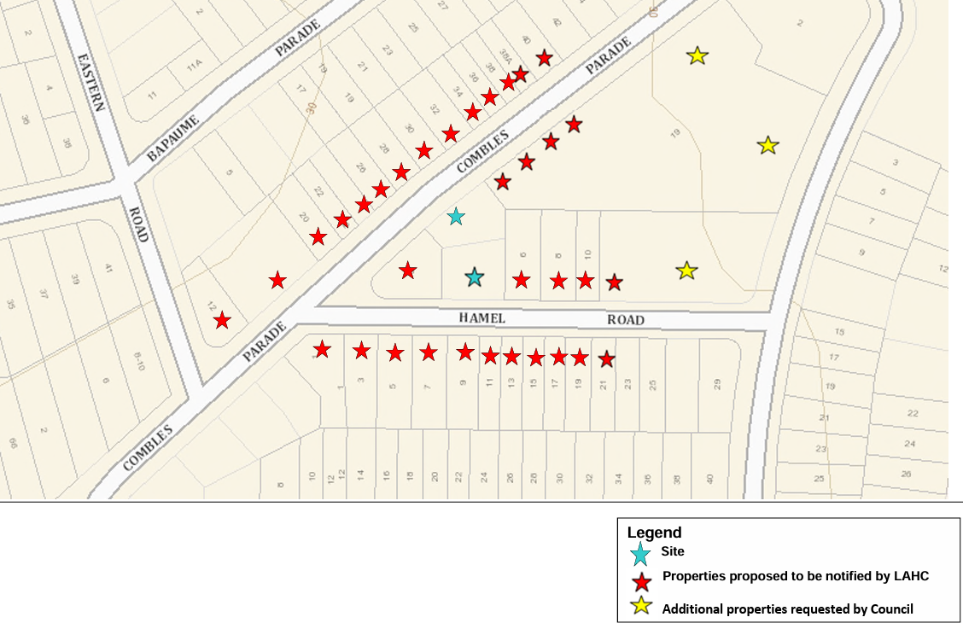
Figure 16 Map of Properties Notified of the Proposed Development (Source: Homes NSW)

Under section43(1)(b) and 108C(1)(b) of Housing SEPP, owners / occupiers of adjoining land, as identified in the above map, were notified of the proposed development activity by letter dated 6 November 2023. Confirmation of the scope of notification by council, the notification letter to Council and a sample of the letter sent to owners/occupiers of adjoining properties are provided at Appendix E
The notification response period formally closed on 1 December 2023 with 3 submissions received raising the following concerns.
Table 14 Issues raised in Resident submission
Matter raised | LAHC Response
- Traffic and parking assessment is flawed with on-street parking not readily available. Insufficient parking provided for the site. | - As part of the planning process, LAHC commissioned an independent traffic and parking report to assess the potential impact of the development. The assessment indicated that the proposed development would generate 3 additional vehicle trips during the peak periods, which is not considered to have a significant impact on the traffic in the local network. In relation to car parking, the development provides 4 car parking spaces on the site, which exceeds the requirements of the State Environmental Planning Policy (Housing) 2021. Furthermore, data indicates that 52.3% of social housing tenants do not own a car in comparison to 18.2% for private tenants in the Randwick Local Government Area (LGA).
- Waste management concerns and cleanliness of the street. Some areas along the street are utilised as a permanent rubbish dumping zone. | - The submitted Waste Management Plan prepared as part of this application details the estimated generation of waste as a result of the demolition/construction phase as well as ongoing use of the development.  - The proposal provides for adequate allocation of garbage bins as per Council’s requirements. Further to this, the plan provides details of waste management including how waste will be gathered by the designated caretakes of the site and assembled at the specified collection point along the street kerb.
- Requesting the fencing to match the colour of the adjoining property. | - Fencing has been proposed in grey to match neighbouring fencing.
- Request to make Combles Parade a one way Street. Street is too narrow for 2 cars. | - This request is under Council’s jurisdiction and not a matter for consideration as part of the assessment of this application.

  - Notification of Specified Public Authorities
The development is “seniors housing” under section 108A of the Housing SEPP. As required by Section 42(5) and 108B(2) of the Housing SEPP, consideration has been given to the need to notify the “specified public authorities” identified in State Environmental Planning Policy (Transport and Infrastructure) 2021, Sections 2.15 and 2.17. The development is not located in an area that triggers the requirement to notify public authorities other than Council.
- Review of Environmental Factors
Environmental factors associated with the proposed activity in terms of location, character, bulk and density, privacy, solar access and overshadowing have been considered in accordance with the provisions of the Housing SEPP and discussed in Section 5.5.1 of this REF. A review of other environmental factors associated with the proposed activity, and the measures required to mitigate any adverse impacts to the environment, are provided below.
  - Neighbourhood Character
The site is located within an established residential area generally supporting single and 2-storey detached dwelling houses and 2-storey multi-unit housing. The dominant form of development in the locality is older style detached, single-storey, brick dwellings. These dwellings tend to sit within lightly landscaped and lawned allotments and have predominately tiled, pitched roofs. The character of the area is evolving, with a number of newer, two-storey dwellings interspersed throughout the locality.
The bulk and scale of the proposed development will be compatible with the evolving character of the neighbourhood and will deliver a built form outcome permissible within the planning controls for the locality and character. The proposed housing represents a contemporary, high quality design. The use of face brick for external walls and metal roofing is consistent with the developing character of the Matraville suburb. The 2-storey design, siting, layout and landscape setting of the proposed development aligns with that of emerging development in the locality.
Mitigation Measures
No mitigation measures are required, as the design of the proposed development is sympathetic to the emerging neighbourhood character and complies with setback requirements under Randwick DCP. Suitable design treatments, including fencing, landscaping both within the site with a considered planting mix and planting of new street trees along Combles Parade and Hamel Road will ensure the proposal contributes to the emerging neighbourhood character.
  - Bulk and Density
The proposed development is consistent with the bulk and scale of surrounding newer developments in the locality of Matraville. The 2-storey building incorporates compliant setbacks distinguished by a variety of articulation features, landscaping, external finishes and materials to reduce the visual bulk of the development.
The proposal incorporates a maximum height of 7.5m which is generally consistent with a low-density residential area. The 2-storey built form is sympathetic to the surrounding context and is an appropriate response to the desired future character envisaged for the R2 Low Density Residential zone.
The proposal incorporates a floor space ratio of 0.5:1 and a maximum height of 7.5m which is generally consistent with a low-density residential area. The FSR and 2-storey built form is sympathetic to the surrounding context and is an appropriate response to the desired future character envisaged for the R2 Low Residential zone, which encourages a variety of housing types and densities. Although the development is classified as a seniors housing development, the overall built form is similar to two-storey dwellings within the locality and provides consistency with the objective of the RLEP 2012 that encourages housing that meets the needs of the locality.
The proposed development complies with the floor space ratio standard, includes generous setbacks from all boundaries and will provide expansive deep soil areas, which will all minimise the building’s perceived bulk. The proposal includes new plantings of native species, new street tree plantings along the two streetscapes, and retention of specified existing mature trees which further softens the bulk of the development.
Accordingly, the proposal is for a development of a bulk, scale and density that does not constitute an overdevelopment of the site. The proposal will suitably increase housing density which is consistent with State and regional strategies and the development controls applying to the site.
Mitigation Measures
No mitigation measures are required.
  - Streetscape
The architectural style of the proposed development activity is compatible with the evolving form and treatment of development in the surrounding locality. The street façade is broken up through a number of distinct architectural elements, separated with landscaping, indentations and materials, colours and finishes, resulting in a finer grained streetscape appearance. In addition, the hard stand car parking area will be obscured from street view, resulting in a built form that integrates with the evolving streetscape.
With its strong articulation and modulation along the front façades and improved landscaping proposed within the street setback areas, the proposed development makes a positive contribution to the Combles Parade and Hamel Road streetscape. The proposed development will provide a new contemporary residential development that will replace 2 aging single storey dwellings.
The built form has been designed to address the street frontages through incorporation of street facing windows and doors, as well as courtyards and balconies within the front setback, improving casual surveillance of the street.
Mitigation Measures
No mitigation measures are required.
  - Visual Impact
The proposed development will generate some short-term visual impact on the surrounding area during construction, with a long-term positive visual impact associated with the establishment of new dwellings in an existing urban residential context.
The proposed development will make a positive contribution to the residential streetscape through the construction of new contemporary dwellings that respond to the site context and emerging neighbourhood character. Articulation, diverse mix of materials and a neutral colour palette will assist with the overall aesthetic of the site.
Landscaping proposed along the front elevations include new, native canopy trees with a mature height of up to 10m will soften the visual impact of dwellings when viewed from the public domain and provide additional canopy and shade to pedestrians and improve the aesthetic quality of the streetscape. The communal open space area in the centre of the site is also co-located with heavily landscaped areas to further assist in softening the built form as well as providing long-term visual amenity for the enjoyment of residents. Mitigation Measures
No mitigation measures are required.
  - Privacy
A high level of internal and external privacy is maintained by the proposed development activity through a range of measures including careful and considered site landscaping, new 1.2-1.8m high fencing, adequate site setbacks and strategic placement of windows so as to avoid direct overlooking of neighbours. In particular:
- The proposed dwellings have been designed in accordance with the requirements of the National Construction Code for sound and impact transmission so that acceptable noise levels between dwellings and adjoining properties are achieved;
- Visual and acoustic privacy within the development and to adjacent neighbours is provided and maintained through the strategic use of privacy screens, considered window locations including high sill windows, and screen planting;
- The front setbacks are consistent with RDCP 2012 and the prevailing building line on Combles Parade and Hamel Road and includes substantial landscaping to further mitigate privacy impacts;
- Side setbacks are compliant with RDCP 2012. The building is setback more than 3m from side boundaries with proposed planting utilised in these areas to provide privacy for adjoining dwellings;
- Extensive landscaping has been provided within the side and front setbacks to provide a visual buffer between the windows and balconies on the subject site, adjoining properties to the east and west and properties opposite the site to the north and south.
- Proposed 1.2m-1.8m metal fencing will mitigate unacceptable overlooking to and from adjoining properties;
- First floor balconies facing both street frontages will enable passive surveillance of the street without compromising the privacy of the internal bedrooms associated with these balconies;
- Private open spaces and balconies have been oriented to the front and rear of the site, and as such will not directly overlook the windows or private open space at adjacent sites;
- Principal private open spaces are set back from neighbouring properties with privacy screens and landscaping provided to ensure privacy;
- Private open spaces and balconies have been oriented to the front and rear of the site, and as such will not directly overlook the windows or private open space of adjacent sites;
- Landscaping is provided along the length of the driveway and around the parking area to ensure privacy to units adjoining these features; and
Mitigation Measures
No mitigation measures are required.
  - Solar Access
The design and siting of the proposed development will provide adequate daylight access to the proposed dwellings living areas, private open spaces and the private open space areas of neighbouring properties in accordance with the Seniors Living Policy: Urban Design Guidelines for Infill Development. The submitted Architectural Plans indicate that 87.5% of dwellings receive at least 2 hours direct solar access to the living and POS areas on June 21 which meets the HSEPP requirement for 70% of dwellings to achieve 2 hours of direct solar access to the living and POS areas mid-winter.
Shadow diagrams also confirm the proposed development will facilitate sunlight to living areas and private open space of the dwellings on adjoining sites.
Proposed living and open space areas have been carefully sited to maximise solar access and the proposal is consistent with the Housing SEPP requirements.
Mitigation Measures
No mitigation measures are required.
  - Overshadowing
Shadow diagrams in Appendix A confirm the proposed development will not generate unacceptable shadow impacts to living areas and private open space of dwellings on adjoining sites.
The shadow diagrams show that throughout the day, shadows will largely be contained within the subject site, with incursions into 11a Combles Parade to the west in the morning and shadowing upon 6 Hamel Road to the east in the afternoon from 2pm onwards. A public road exists to the north and south. The favourable orientation of the site and surrounding properties means that all adjacent properties will continue to receive substantial areas of sunlight to their private open spaces, in excess of 3 hours, at mid-winter.
The level of overshadowing of 11a Combles Parade will result in this site losing sunlight in the morning. Shadows will move to the east around midday, meaning that this site will achieve sunlight in the afternoon. Conversely, 6 Hamel Road will lose sunlight in the late afternoon, but maintain more than 3 hours in the morning and midday. Accordingly, there are no unacceptable impacts.
Mitigation Measures
No mitigation measures are required.
  - Traffic & Parking
A total of 4 car parking spaces for residents, including 2 accessible spaces, will be available on site to serve the proposed development. The provision of on-site car parking exceeds the parking requirements set out in the Housing SEPP for developments carried out by LAHC by 2 spaces. This increased car parking provision is considered appropriate and will ensure car parking demands are contained within the development. As such, this proposed provision is considered acceptable and would result in a public benefit, thereby improving the amenity of other residents in the locality. Notwithstanding, unrestricted street parking is available on Combles Parade and Hamel Road adjacent to the site to accommodate any overflow parking demand generated by the proposed development.
A Traffic Impact and Parking Assessment prepared by Greenview Consulting (Appendix V) indicates that the development will have a projected nett increase in 3 vehicle per hour in the AM and PM peak hour, which is equivalent to the traffic generated from the existing land uses on the subject site. Therefore, the proposal will not have any unacceptable implications in terms of road network capacity.
The Traffic Impact and Parking Assessment examined the adequacy of the proposed internal driveways and parking arrangement. Vehicular access to the off-street vehicle parking is proposed via one ingress / egress driveway connecting with Combles Parade on the eastern side of the site. The assessment confirmed that the proposed access and internal circulation are satisfactory based on an assessment of the projected vehicle movements.

Mitigation Measure
Identified Requirements No. 10, 11 & 12 has been recommended to ensure appropriate construction of vehicular access and parking on site.
Locations of wheel stops, bollards and other traffic furniture to be indicated during construction documentation stage to satisfy the relevant Australian Standard. Wayfinding signage to be placed within the proposed car parking area to assist visitors with circulating the site.
  - Flora and Fauna
An Arboricultural Impact Assessment has been prepared for the site by Redgum Horticultural (Appendix J).
The report recommends the removal of 3 existing trees that are located within the proposed development footprint or that would be impacted by an unavoidable major encroachment within the tree protection zone. It also recommends retention of 7 existing trees (Tree Nos. 1, 2, 3, 4, 7, 8 & 9).
Tree Nos. 5, 6 & 10 are located within the construction zone and are recommended for removal subject to approval from the consent authority.
More appropriate replacement planting of tree species is proposed, as indicated on the landscape plan and details. The new plantings will provide replacement tree cover on the site and increase the variety of species, including flowering trees, which will provide additional habitat for fauna in the long-term.
There will be no significant impact on native fauna as a result of the proposed development, given that compensatory planting is proposed.
Mitigation Measures
Retained trees are to be protected in accordance with the recommendations and General Tree Retention Specification contained within the Arboricultural Impact Assessment and Tree Management Plan (refer Appendix J and Identified Requirement No. 44).
  - Heritage (European / Indigenous)
No heritage items are identified Randwick City Council’s Section 10.7(2) & (5) Planning Certificates located on or in the vicinity of the site.
Aboriginal Heritage
An Aboriginal Heritage Information Management System (AHIMS) search, dated 31 October 2023 (Appendix I) did not find any record of Aboriginal Sites or Places on the site or in the surrounding locality. Consideration of the Due Diligence Code of Practice for the Protection of Aboriginal Objects in New South Wales, determined that no additional investigation was warranted. Discovery of cultural material during development activities cannot be ruled out, however and an identified requirement has been applied should any Aboriginal relics be discovered on the site during excavation/construction.
Other Cultural Heritage
No cultural heritage items have been identified in Randwick City Council’s Section 10.7 Planning Certificates and the likelihood of any heritage relics being discovered during excavation / construction is considered to be minimal.

Mitigation Measures
An Identified Requirement (No. 46) has been applied should any cultural heritage relics be discovered on the site during excavation / construction.
  - Soils / Contamination / Acid Sulfate Soils / Salinity
Geotechnical
A Geotechnical Investigation and Acid Sulfate Soil Assessment, prepared by STS Geotechnics indicates the following:
- The subsurface conditions consist of topsoil overlying silty sands.
- The topsoils are present from the surface to a depth of 0.3m and 0.4m.
- Loose, becoming medium dense with depth, silty sands underlie the topsoil to the depth of drilling 3.0m
- Medium dense sands could not be penetrated beyond a depth of 1.4 and 0.9 m.
- No groundwater was observed during drilling works.
Mitigation Measures
During construction, should the subsurface conditions vary from those inferred in the Geotechnical Investigation, STS Geotechnics Pty Ltd are to be contacted to determine if any changes should be made to recommendations.
The exposed bearing surfaces for footings should be inspected by a geotechnical engineer to ensure allowable pressure given has been achieved.
Contamination
According to Council’s Section 10.7 Planning Certificates, the land is not affected by a policy restriction relating to contaminated land. Furthermore, historical site investigations of the land do not reveal or indicate that the site has been used or exposed to potential contamination.
Mitigation Measures
An Identified Requirement (No. 17) has been recommended to cover the possibility of discovering site contamination during demolition / construction works.
Acid Sulfate Soils
According to Council’s Section 10.7 Planning Certificates, the land is not affected by acid sulfate soils.
Mitigation Measures
No mitigations measures are required.
Salinity
Council’s Section 10.7 Planning Certificates indicate that Randwick Council has not adopted a policy on salinity.
Mitigation Measures
No mitigation measures are required.
  - Drainage / Flood Prone Land / Hydrology/ Water Quality
Stormwater drainage for the proposed development has been designed in accordance with Council’s requirements. Stormwater will be collected via a series of stormwater pits and drains on the site connected to an underground detention tank draining to the existing stormwater network along Combles Parade and Hamel Road. An underground rain water tank is located adjacent to the OSD tank.
The Section 10.7 Planning Certificates issued by Council for the subject site indicate that the land is not subject to flood related development controls. The proposed development has been designed to have no adverse impact on the hydrology or water quality within the local area.
Mitigation Measures
Identified Requirements (Nos. 6-9, 14, 34, 35 & 72) have been recommended to ensure that stormwater drainage is managed in accordance with legislative requirements.
  - Bushfire Prone Land
The Section 10.7 Planning Certificates issued by Randwick City Council for the subject site advise that the land is not bushfire prone.
Mitigation Measures
No mitigation measures are required.
  - Noise and Vibration
During Demolition / Construction
During demolition/construction typical noise levels associated with demolition/ building works will be generated within the hours of 7am to 5pm Monday to Saturday, consistent with the requirements for complying development.
During Occupation
Noise generated when the proposed buildings are completed and occupied will be entirely in keeping with their residential surroundings. No major plant or equipment, which would generate unacceptable noise during occupation, will be installed in the proposed development.
Buildings will be constructed to comply with the deemed-to-comply provisions of the Building Code of Australia with respect to noise transmission.
Mitigation Measures
Demolition/construction noise will be controlled to within acceptable limits by sound attenuation measures and undertaking construction activities within EPA/local council requirements.
Buildings will be constructed to comply with the deemed-to-comply provisions of the Building Code of Australia and EPA criteria with respect to noise transmission.
Appropriate Identified Requirements (Nos. 1, 58 & 60) have been applied to ensure compliance with the above.
  - Air Quality
Temporary and localised air quality impacts including dust, smoke, grit, odours, and fumes might be generated during the clearing and excavation of the site and construction of the proposed development.
Mitigation Measures
Appropriate Identified Requirements (Nos. 61, 64 & 65) have been applied that will satisfactorily mitigate any potential or adverse impacts on air quality.
  - Waste Minimisation
The following waste minimization and management measures have been identified and are to be considered in conjunction with the specific details, including the estimated quantities of waste, provided in the final waste management plan to be prepared by the demolition/building contractor.
During Demolition
Demolition materials will be stored wholly within the site prior to removal for recycling or disposal. Demolition waste will be removed from the site to an approved waste management facility or will be recycled, as follows:
- All waste disposal will be to approved waste management centres.
- Concrete waste to be re-used for fill where possible with excess to be removed off site for recycling at a recycling centre.
- Brick off-cuts and waste to be re-used for fill where possible with excess to be removed off site for recycling at a recycling centre.
- Excavation material – topsoil to be retained and stored on-site for re-use. Surplus material to be removed from site for recycling.
Specific intentions for recycling / re-use / disposal of demolition waste will be determined by the construction contractor prior to commencement of demolition.
During Construction
Construction materials must be stored wholly within the site prior to removal for recycling or disposal. Construction materials waste must be removed from the site to an approved waste management facility or shall be recycled as follows:
Excavation material
- Topsoil retained on-site for re-use
Surplus material removed from site for recycling
Building – Excess Material
- The primary material waste will be concrete, brick, timber and plasterboard material.
- All excess material will be removed from the site for recycling.
Building – Materials Packaging
- All plastic and metal will be pre-sorted and separately disposed of to an approved waste management centre.

During Occupation
General and non-recyclable waste will be disposed of in Council’s standard waste storage bins located in the garbage storage enclosures and placed on the street kerb for collection by Council’s waste services.
Paper / metal / glass will be disposed of in Council’s standard waste recycling bins to be located in the garbage storage enclosures and placed on the street kerb for collection by Council’s waste services.
Mitigation Measures
Identified Requirements (Nos. 49 - 56) are recommended to ensure construction/demolition waste is appropriately managed and disposed of. An Identified Requirement (No. 45) is recommended to require the preparation of a final waste management plan for the demolition, construction and occupation phases of the development.
  - Resource Use & Availability
The proposed activity will not result in any discernable depletion or degradation of natural resources. The proposal has been designed to meet water and energy efficiency targets as demonstrated by the BASIX certificate for the proposal.
The recycling and reuse of materials during demolition, construction and on-going occupation of the proposed development will reduce the consumption of natural resources.
The proposed development is for the replacement of existing housing that has reached the end of its economic lifespan. The proposed development will provide contemporary housing that will satisfy current State Government environmental sustainability requirements, particularly through improved energy and water efficiency. These factors will ensure reduced depletion and degradation of natural resources in the long term.
Mitigation Measures
No additional mitigation measures are required.
  - Community / Social Effects
The proposed development will generate a number of positive community and social effects, including:
- assist Homes NSW in meeting its significant, long-standing and continually-growing demand for social housing in the Randwick local government and surrounding area wherein the expected waiting time for a 1 bedroom dwelling in Matraville is 5-10 years, as at 30 June 2022 (CS02 Eastern Suburbs zone),
- assist Homes NSW in improving the amenity of accommodation for its tenants, by providing new, more appropriate housing aligning with demand for social housing;
- improve the environmental sustainability of housing on the site, particularly through improved energy and water efficiency; and
- provide more accessible housing on the site.
Mitigation Measures
No mitigation measures are required.
  - Economic Impact
The proposed development is likely to contribute to a range of economic benefits in the Randwick local government and surrounding areas through:
- more efficient use of land resources, existing infrastructure and existing services;
- local sourcing of construction materials, where available;
- the local sourcing of tradespeople and other construction-related professionals, where possible;
- on-going consumption from new/ additional households;
- the reduced maintenance costs of the newer housing; and
- Savings associated with improved energy and water efficiency.
Mitigation Measures
No mitigation measures are required.
  - Cumulative Impact Assessment
The proposed activity is not likely to have singular or cumulative environmental impacts which would result in unacceptable adverse effects for the following reasons:
- the proposed activity will not result in any adverse cumulative impact when considered in conjunction with any other proposals or developments in the area;
- there will be no synergistic effects of individual project impacts from the proposed activity when considered in combination; and
- There are no known environmental stresses in the area of the proposed activity that would be increased.
Mitigation Measures
No mitigation measures are required.

- Conclusion
  - Summary of Key Issues Raised in Assessment
The proposed activity, given its scale, location and design, will be sympathetic with its residential environment. Following a review of the site constraints, it has been determined that the subject land does not contain any significant environmental hazards and that there are no key issues that have been identified that require further assessment.
The proposed activity has been considered in terms of the provisions of Section 5.5 of the EP&A Act and Section 171 and 171A of the EP&A Regulation. In this regard, it should be noted that following an analysis of the potential impacts associated with the proposed activity it was determined that an environmental impact statement is not required.
As demonstrated in this REF, the proposed activity is consistent with the relevant objectives and standards set out in the Housing SEPP, RLEP 2012, and the design principles and better practices set out in the relevant guidelines.
In addition, and as demonstrated by the environmental impact analysis and assessment undertaken in this REF, the proposed activity will have environmental impacts that can be mitigated to an acceptable level in accordance with current applicable standards, will have a number of positive environmental effects in terms of the built environment and will deliver a range of social and economic benefits.
The proposed development will enable LAHC to meet the increasing demand for 1 bedrooms seniors housing dwellings in the local area. Therefore, the proposed development is clearly in the public interest.
  - Recommendation
Given the above review of environmental factors, it is recommended that LAHC proceed with the proposed activity subject to the implementation of the Identified Requirements listed in the Activity Determination.

APPENDIX A – ARCHITECTURAL PLANS

APPENDIX B – LANDSCAPE PLANS

APPENDIX C – CIVIL PLANS

APPENDIX D – SURVEY PLANS

APPENDIX E – NOTIFICATION PLANS

APPENDIX F – SECTION 10.7 PLANNING CERTIFICATES
APPENDIX G – NOTIFICATION LETTERS, SCOPE OF NOTIFICATION

APPENDIX H – ACCESS REPORT

APPENDIX I – AHIMS

APPENDIX J – ARBORIST REPORT
APPENDIX K – BASIX CERTIFICATE
APPENDIX L – BCA REPORT

APPENDIX M – DESIGN COMPLIANCE CERTIFICATES

APPENDIX N – NATHERS CERTIFICATE

APPENDIX O – HOUSING FOR SENIORS CHECKLIST

APPENDIX P – GEOTECHNICAL INVESTIGATIONS

APPENDIX Q – TITLE SEARCH AND DP

APPENDIX R – WASTE MANAGEMENT PLAN

APPENDIX S – TRAFFIC IMPACT ASSESSMENT

